0⁻74⁻,11,a .3a VII al..6 1.1  19  592. ⁵⁹⁵1.1 •.,..dp,  2 55521 51.6 .¹¹96 295  '11111.11 ',Z=4`.."."..7,1" | ^{n" 4 r}".'''g'"  p44....1*, pi. L..0  . , t: =  7 7^ 7,, . |  |  |  | UOld 0115 4CIOOLioa spoddy 6u1uo2 A p.ax)e  Isom g sauna '41-10N S£ ^{chtitumoi} '61. uollosS  .98294 Duoipui ‘osirmodiDA _{'Pood} memmooe | .96'3O  II | I azzon-st-s-scsoN1 | I I | 0  .1 133 45
NIO Wilk° 1AT
NIO Wilk° 1AT | '''4²⁷.⁷'.—  „
^{PE} 0

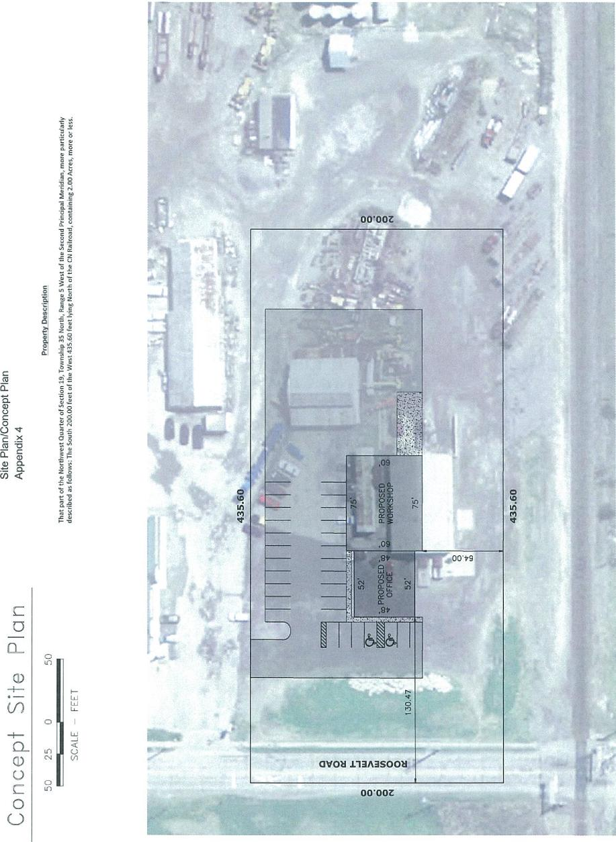
O
0
0
L1
Cr)
0
SCALE - FEET
0
1.1)
0
C
O

