A Zone Improvement Plan for Parks & Recreation Facilities City of Valparaiso Parks & Recreation Department

The proposed:
City of Valparaiso Recreation Zone
Improvement Plan 2015-2024
For:
City Parks & Recreation Facilities
Prepared for:
City of Valparaiso Park Board
City of Valparaiso Plan Commission City of Valparaiso City Council
Valparaiso, Indiana
Prepared by:
Lehman & Lehman, Inc.
Landscape Architects | Planners | Placemakers Mishawaka, Indiana
With Review by:  Tim Burkman, P.E. City Engineer  City of Valparaiso  October 2015 | 

The proposed:
City of Valparaiso Recreation Zone
Improvement Plan 2015-2024
This report was prepared under contract for the Department of Parks and Recreation, City of Valparaiso by:
Charles F. Lehman, ASLA, FRSA  President, Lehman & Lehman, Inc.  Landscape Architects j Planners j Placemakers 510 Lincolnway East, Suite C  Mishawaka, Indiana 46544 | 

With Review by:
Tim Burkman, P.E., Reviewing Professional Engineer, City of Valparaiso
Completed October 2015
The information, analysis, ideas, designs and concepts contained herein are the exclusive intellectual property of Lehman & Lehman, Inc. Except as it is used by the Valparaiso Parks and Recreation Department / Board in direct relation to the study’s implementation, no part of this publication may be reproduced or used in any way without expressed written permission by Lehman & Lehman, Inc. All rights reserved.
Copyright © 201 5 – LEHMAN & LEHMAN, INC.
October 2015

In 1991, the Indiana General Assembly passed an impact fee bill that created an alternative funding mechanism for infrastructure improvements in fast growing areas. The essence of the legislation was to allow local governments the option of passing onto new residents the cost of building the new infrastructure demanded by those same new residents.
This Infrastructure Improvement Plan for Parks and Recreation Facilities (Recreation Impact Fee Study) for the City of Valparaiso is our third update of this impact fee. Our last study was completed in 2010. This update started several months ago, following the process as outlined by the 1991 Indiana Code. A Recreation Impact Fee Advisory Committee was established and worked with the Consultant in updating the current recreation component inventory along with the related standards. This update evaluated the recreation impact zone established in the last update. Population projections were arrived at by analyzing existing developments with capacity as well as new development parcels of the planning area, related residential building permits were forecasted, both current and future recreation component deficiencies were calculated, and costs for these infrastructure deficiency improvements were established for both current (2015) and future (2024) needs. The impact fee for the impact fee zones were determined by dividing the estimated costs of the 10-year deficiencies by the number of projected residential building permits of each impact zone during that same period.
You will recall that Recreation Impact Fees are collected prior to the issuance of each residential building permit, and the first collection will occur six (6) months after the final approval by the City Council of the Impact Fee ordinance. The fees are then placed in an interest bearing account, and related expenses for improvements are then paid from that account. Since impact fees cannot be used to fund current deficiencies, those improvements will need to come from other resources of the City. Recreation Impact Fees can only be used for the costs of the projected 10-year deficiencies determined by future populations.
An impact fee may not be collected for more than five years without a review and update of the Infrastructure Plan and adoption of the fee by City Council. Attached is a new Infrastructure Improvement Plan. The Parks and Recreation Staff prepared the plan with assistance from Lehman & Lehman, Inc. After preparation, the plan was submitted to Tim Burkman, P.E. (City Engineer, Valparaiso, Indiana), for final review and approval. The plan establishes new park and recreation standards for Valparaiso and recommends a one-zone structure and Recreation Impact Fees that will be necessary in order to achieve the City of Valparaiso ’s Park and Recreation standards.
After careful analysis, the Valparaiso Park Infrastructure Advisory Committee and the Park Administrative Staff feels that the recommended Recreation Impact Fee of $1,288 is a responsible fee for the recommended standards. The Valparaiso Park Infrastructure Advisory Committee recommends acceptance of the fee by the Valparaiso Parks and Recreation Board before being placed before the Valparaiso Planning Commission and City Council for final adoption.
Adoption of these parks and recreation standards will ensure the continued delivery of quality parks and Recreation services for all of the Citizens of Valparaiso.
Sincerely,
John Seibert, Director Valparaiso Parks and Recreation

Acknowledgements
City of Valparaiso Park Infrastructure Advisory Committee
Committee Members:
- Jeff Lewis , Architect, Parks Foundation President
- Christa Emerson, Park Board, Vice President
- Matt Evans, Realtor and Broker
- Trista Hudson, City Council Liaison to Park Board
- Dan Steiner, Builder, President, Porter County Home Builders Association
Staff and Consultant Members
- John Seibert, Park Director
- Barbie Johnson, Assistant to the Park Director
- Steve Antonetti, Director of Business Operations (Valpo Parks)
- Tyler Kent, City Planner
- Tim Burkman, City Engineer
- Chuck Lehman, Lehman & Lehman, Inc. (Consultant)
Mayor  - Jon Costas  Common Council |  | Clerk Treasurer  - Sharon Swihart
• | Bob Taylor , District 1 | • | John Bowker, District 5
• | Tim Daly, District 2 | • | Jan Dick, At Large
• | Joey Larr, District 3 | • | Trista Hudson, At Large
• | Michael Baird, District 4 | • | Jon Costas, Mayor
Park Board
• | Tim Warner, President | • | T.J. Edwards
• | Ric Frataccia, Vice President | • | Christa Emerson Borlick
• | John Seibert, Secretary
Plan Commission
• | Bruce Berner, President | • | Helene Pierce, Secretary
• | Tim Burkman, City Engineer | • | Matt Evans
• | Deb Butterfield, City Council | • | Ethan Lowe, Attorney
 | Appointment

Table of Contents
PREFACE
Cover Letter | 3
Acknowledgments | 4
Table of Contents | 5
Executive Summary | 7
Recreation Impact Fee Study Process | 11
Population and Residential Development Trends | 12
Expectations of Population Growth / Residential Building Permit Projections | 21
Existing Park Land Facilities | . 22
Existing Infrastructure of Recreation Facilities | 25
Community Level of Service Needs and Cost Estimates | 29
Recommended Recreation Impact Fee | 31
Summary of Impact Fee Study | 39
APPENDIX
Appendix A: Indiana Code (IC) 36-7-4-1300 | 44
Appendix B: Fixed Assets / Capital Improvements over the years 2010-2014 | 63
Appendix C: Summary of Valparaiso Park Department Revenues 2009-2014 | 64
Appendix D: Impact Fee One Zone Recommendation Logic | 64
Appendix E: Park and Recreation Infrastructure Inventory | 65
Appendix F: RIF Collections and Disbursements 2005 to 2014 | 66
Appendix G: Letter of Study Review from Reviewing Professional Engineer | 67
LIST OF TABLES
Table 1 – Valparaiso Potential Residential Growth Work Sheet of Undeveloped Land Parcels | 16-18
Table 2 – Valparaiso Potential Residential Growth Work Sheet of Existing Developments | . 19
Table 3 – Potential Residential Growth Summary | 20
Table 4 – Current and Projected Population and Building Permit Growth | 21
Table 5 – Park Site Inventory | 23
Table 6 – Land Inventory – Current Level of Service and Community Level of Service | 24
Table 7 – Facilities Inventory and Needs | 26
Table 8 – Current Deficiencies and Future Needs | 27
Table 9 – Acreage Needs for Recreation Components | 28
Table 10 – Cost of Recreation Components to Overcome Current Deficiencies and Future Needs | 29
Table 11 – Recreation Impact Fee Scenarios | 30
Table 12 – Recreation Impact Fee Scenario Summary of “A” Priorities | 31
Table 13 – Funding Sources for Current Deficiencies | 31
Table 14 – Forecast Annual Funding for Current Deficiencies | 32
Table 15 – Impact Deduction Calculations | 33
Table 16 – Future Need Recreation Components and their Costs | 33
Table 17 – Recommended Recreation Impact Fee Calculation | 34
Table 18 – Recreation Impact Fee Revenue Calculations | 35
Table 19 – Implementation Schedule for Current Deficiencies | 37
Table 20 – Implementation Schedule for Future Needs | 37

Valparaiso Recreation Zone Improvement Plan Study
LIST OF FIGURES
Figure 1 – Illustration of Planning Jurisdiction 9
Figure 2 – Community Level of Service Illustration 11
Figure 3 – Valparaiso Residential Growth History 12
Figure 4 –City of Valparaiso 2013 Future City Growth 13
Figure 5 – City of Valparaiso Annexation Areas Plan 14
Figure 6 – Valparaiso Residential Growth Potential 15
Figure 7 – Historic and Projected Population of the City of Valparaiso 22
Figure 8 – Recreation Impact Fee Revenues Graph 35
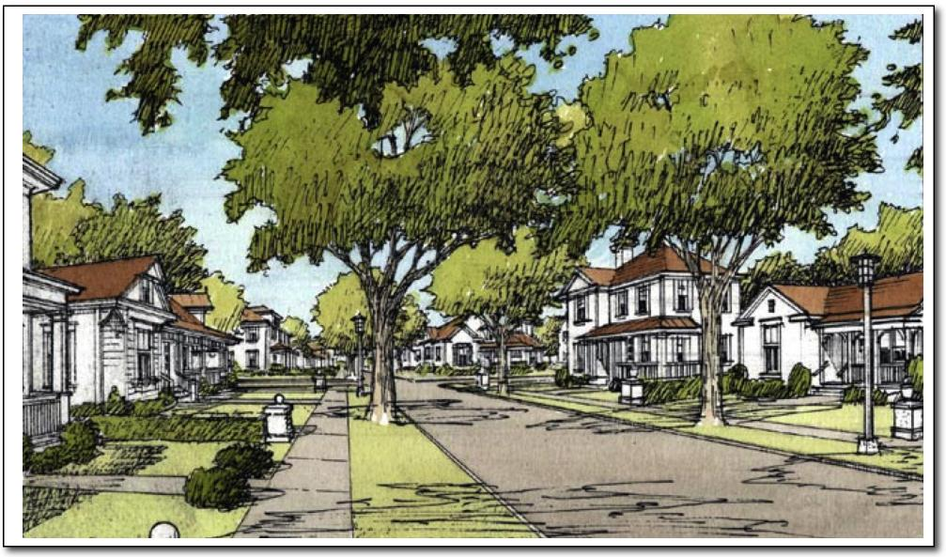

Executive Summary
Background
The residential growth of the City of Valparaiso and its surrounding area has, over the past decades, experienced significant growth in residential development. As a result, the public infrastructure systems (roads, drainage, water/sanitary utilities and parks) are, or will become, strained to keep pace with the demands placed on them.
In anticipation of these demands, the City of Valparaiso is in the process of implementing and updating one of these public infrastructure systems by way of a Recreation Impact Fee Ordinance. Both the City’s Envision 2030 Comprehensive Plan 2013 and the Parks and Recreation Master Plan Update 2010 have clearly indicated that the demand for recreational facilities will intensify because of the demographics of the growing population base. It is also recognized that a quality system of parks, green spaces and pathways/trails adds to the economic value and quality of life of the entire community.
The demands placed on the Park System by rapid growth have, and will, outpace the City’s financial ability to provide the new and expanded facilities identified in the Parks and Recreation Master Plan. The current revenues are devoted almost entirely to maintaining and operating existing park facilities and programs. New sources of capital improvement revenue are needed. The Recreation Impact Fee Ordinance will continue to benefit the City and community in the future by keeping pace with the population growth while maintaining the level of adopted recreation standards.
The Plan does acknowledge that the 2010 Census data will provide the basis for the data on population and demographics for the City. The City has provided the Consultant with updated population estimates that were used as part of this study analysis .
History of Recreation Impact Fees
In 1991, the Indiana General Assembly passed an impact fee bill that created an alternative funding mechanism for infrastructure improvements in fast growing areas.
The essence of the legislation was to allow local governments the option of passing onto new residents the costs of building the new infrastructure expected by those same residents.
Impact Fees Facts
Need for and Application of Impact Fees
- Best applied to Fast Growing Communities (or projected)
- Considered as an “Entrance Fee” for residents to build and live in the Community
- Funds are applied directly to the infrastructure needs caused by the growth
Different Types of Impact Fees
- Recreation, Roads, Water/Sanitary Utilities, and Drainage
Impact Fee Studies
- Cover 10-year projection period
- Must be updated, at a minimum, every five years
- Also used to define development standards

Valparaiso Recreation Zone Improvement Plan Study
Benefits of Recreation Impact Fees
- Future residents pay for the increased demand on infrastructure services (defined as Community Level of Service)
- Current residents do not bear the burden of infrastructure expansion due to population growth
- Maintains quality of life as community grows
Development Impact Fees
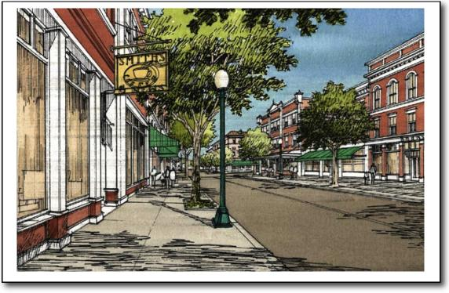
Development Impact Fees, as described by this Zone Improvement Plan (herein Plan), will shift part of the cost of new and expanded park facilities from the community at large to the new developments that are generating the need for those new and expanded facilities. Impact fees, however, cannot be used to finance the current needs of improvements required to raise the Current Level of Service to the Community Level of Service, hereafter referred to as “deficiencies.”
Impact fee logic has long been debated, discussed and endorsed by those who are involved in public finance. In 1991, the Indiana General Assembly enacted legislation [Indiana Code (IC) 36-7-4-1300] (see Appendix A) that enables localities to impose Development Impact Fees for certain types of infrastructure improvements, including park and recreational facilities. Among other things required of the locality, the legislation stipulates that:
- An Impact Fee Advisory Committee be appointed
- An Impact Fee Zone be established
- A Zone Improvement Plan be prepared
- An Impact Fee be determined and
- An Impact Fee Review Board be appointed
Park Infrastructure (Impact Fee) Advisory Committee
The Mayor of Valparaiso appointed a Recreation Impact Fee Advisory Committee in early 2015. The Committee consisted of members of the Park Board and Developers. City staff members of the Planning and Engineering Departments were included in addition to others appointed to fulfill statutory requirements. The Committee, listed on the acknowledgment page, met on several occasions to research and review data, to establish standards for park facilities, and to formulate the plan and strategies as described herein.
Although the City Council has jurisdiction only within the Valparaiso City limits, the Committee concluded early in its deliberations that the Study Area of this Plan should include all of the Valparaiso Planning Area Boundary (the same area as encompassed with its Comprehensive Plan) for the following reasons:
- It is reasonable to expect that some properties adjacent to the current corporate boundaries will become part of the City of Valparaiso in the time frame of this study
- The City is continuing to grow into the planning area through voluntary annexation, and
- The City’s entire land use planning area is within the future service area of the City

Valparaiso Recreation Zone Improvement Plan Study

Impact Zone
In the update study of 2010 a one impact zone was part of the study and ordinance. Through the course of this study (2015) it was determined by the Advisory Committee that a single (one) Impact Zone should continue in best serving the City, residents and the development community.
Within the Study Area, the Advisory Committee recommended the establishment of a single (one) Impact Zone to coincide with the corpora te and Comprehensive Planning boundary of the City as it continues to expand in the future through annexations. Thus, the Impact Zone is expected to expand through annexation until it encompasses the entire Planning Jurisdiction and future areas of annexation in the Township(s) within the County. More particular, the Impact Zone boundaries for the City of Valparaiso are co-terminus with the existing corporate boundaries of the City, as such boundaries may be extended from time to time through annexation, and over which boundaries the City exercises planning and zoning jurisdiction.
Figure 1 is a map that shows the Study Area, which consists of Valparaiso Planning Jurisdiction area and areas that may be annexed in the next five years which constitute the boundary of the Impact Fee Zone. Also shown are the current corporate limits.
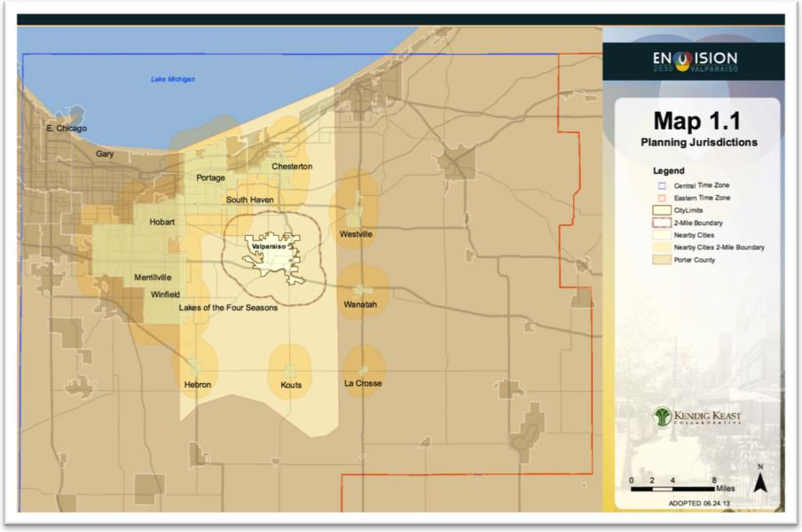
Figure 1 – Illustration of Planning Jurisdictions (source: City of Valparaiso – Envision 2030)
Zone Improvement Plan
The Zone Improvement Plan is described by this document and examines the existing park facilities, and determines the costs to (A) overcome existing deficiencies and (B) to meet future needs according to Community Level of Service standards.

Valparaiso Recreation Zone Improvement Plan Study
Impact Fee Review Board
As required by Indiana Code 36-7-4-1338, and before the Impact Fee is implemented, the City will establish an
Impact Fee Review Board, consisting of Valparaiso citizens. The law requires that the Impact Fee Review Board
include one real estate broker and one engineer, both licensed in Indiana, and one certified public accountant.
Other Planning Efforts Acknowledged in this Plan
As stated above, the City has previously adopted and updated its Comprehensive Plan and Parks and Recreation Master Plan. The City of Valparaiso has adopted the “Valparaiso Pathways and Greenways Master Plan ”. This plan references the existing and proposed trails throughout the study area.
This Recreational Impact Fee study acknowledges the City’s Comprehensive Plan, Parks and Recreation Master Plan, and the Pathways and Greenways Master Plan as constituting the vision for the City and its park system. The Impact Fee recommended in this Plan is a financial strategy that will help achieve that vision.
Conclusions
- The Recreation Impact Fee Advisory Committee recommends to the City of Valparaiso that a new Recreation Impact Fee (RIF) Ordinance be adopted instituting a new Recreation Impact Fee of $1,288. It is also recommended that an annual inflation rate (i.e. Gross Domestic Product annual figure) be factored into the impact fee amount.
- Following the State Code [IC 36-7-4-1340(a)], RIF collection will start six months after approval of the ordinance. The funds collected will be kept in a “Recreation Impact Fee” line item of the City’s Budget.
- The City of Valparaiso should establish criteria, as policy, for the acceptance of land donations for park use and/or open space. Also, the City of Valparaiso, through its Parks Department, will address, annually, the distribution priorities of the RIF revenues.
- The City’s Park and Recreation Master Plan Update, as well as the Valparaiso Pathways and Greenways Master Plan, should reflect the standards and goals established as part of this study.
- Collection of the RIF will occur when residential building permits are pulled. As an option, payments can be established using an installment plan as per IC 36-7-4-1324.
- Reporting of RIF’s transactions will be done annually noting recreation impact fees collected and the disbursements for recreation infrastructure components used as part of the impact fee calculations used during the RIF ordinance period.
- Annual adjustments to the RIF can be considered with annual inflationary factors. A new RIF update study will be considered annually but must be done no later than five years from the date of this study.

Recreation Impact Fee Study Process
The process of defining a Recreation Impact Fee for a community involves a series of steps. Those steps include the following:
- Establish the Park Impact Fee Advisory Committee
- Define the Impact Zone
- Collect current census populations and trends
- Inventory the current recreation infrastructure for land and facilities (Current Level of Service)
- Establish Community Level of Service for recreation land and facilities
- Analyze housing building permits and trends (both inside City limits and within the planning area)
- Analyze current deficiencies and 10-year infrastructure needs based on Community Level of Service and projected population forecasts
- Determine costs for meeting current deficiencies and future needs based on Community Level of Service
- Recreation Impact Fees (RIF) = Future Recreation Infrastructure Need Costs / Projected 10-year Residential Building Permits
(As per IC 36-7-4-1321 which states that the Impact Fee = Impact Costs – Non-Local Revenues – Impact Deductions / 10-Year Forecast Building Permits)
- Prepare a Zone Improvement Plan
- Recommendations to the Park Board and the Plan Commission
- Ordinance for City Council’s Review and Adoption
Figure 2 – Community Level of Service Illustration
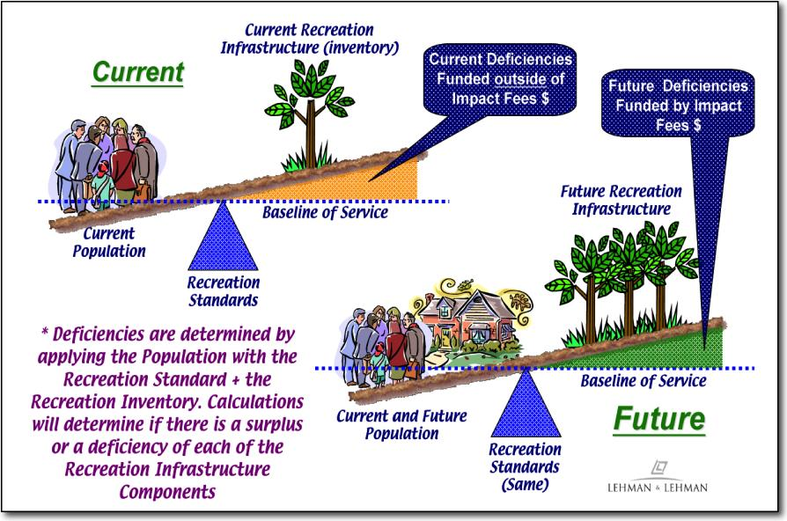

Population and Residential Development Trends
The City of Valparaiso and the surrounding planning jurisdiction area have experienced the significant population growth in recent years since the housing down turn in the last decade . The current growth rate of residential development within the City of Valparaiso (as well as most of Indiana) has been slowly and steadily coming back and is having positive impact by the current economic conditions. It is still anticipated that residential development will continue to pick up again in the next ten years. How much of an increase will continue to be monitored. This study will look at various sources to determine the new residential growth rate over the next ten years. Keep in mind that these projections will be reviewed and updated when this Zone Improvement Plan is updated in the next five years per IC 36-7-4-1340(b).
During the course of this study the Consultant worked closely with the City Planning Department to review upcoming residential developments in both Valparaiso Planning Jurisdiction as well as existing developments where growth remains.
Trends in Residential Building Permits History
Various population projection resources were reviewed including that of the Building Department and U.S. Census, past twenty-year trends in new residential building permits, as well as another population growth model discussed below. Figure 3 (below) illustrates Valparaiso’s Growth History in residential building permits per year between the years 1999 to 2014. The last sixteen-year average was 150 residential building permits per year. Applying the 2.35 persons per household (2010 Census), this annual average of 150 residential building permits would equal an average of 352.5 persons per year.
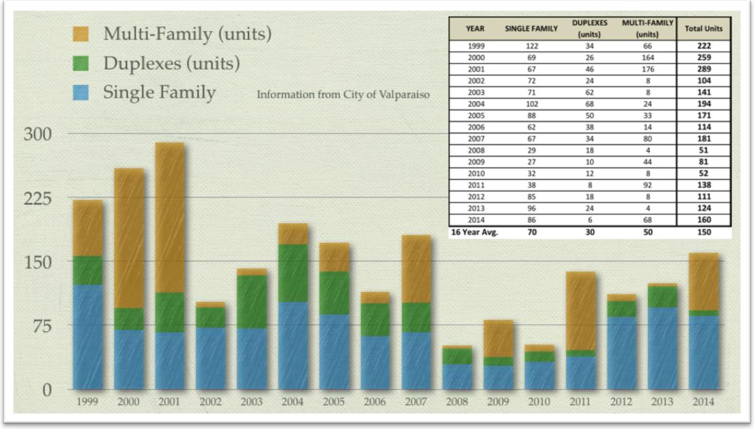
Figure 3 – Valparaiso Residential Growth History

Valparaiso Recreation Zone Improvement Plan Study

Residential Growth Strategies
Future Growth of the City will follow the land use patterns and zoning densities as per the City’s Comprehensive Plan. The following figures illustrate the proposed Development Attractors and Impediments. Below is Figure 4 2013 Future City Growth Plan for Valparaiso.
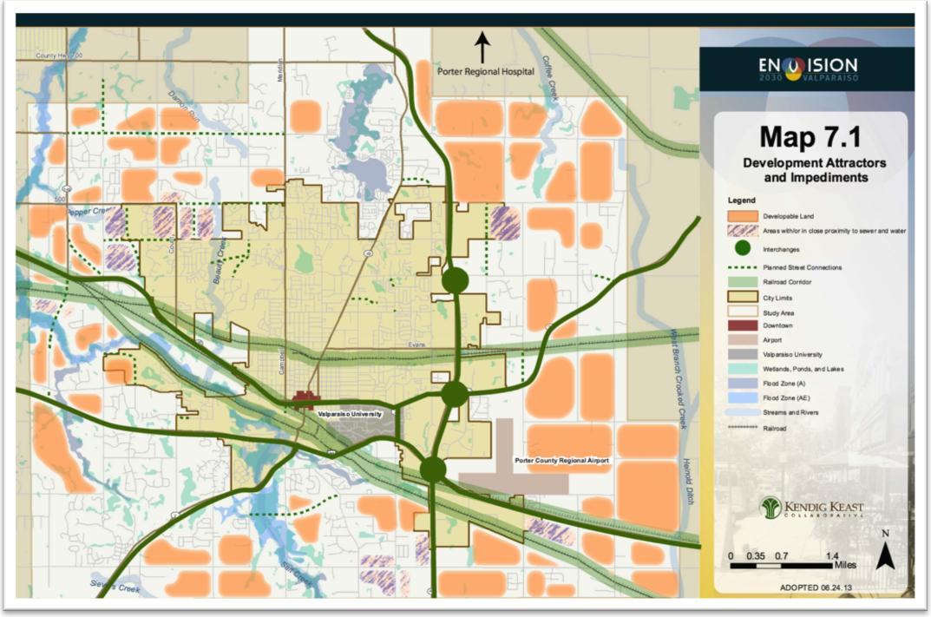
Figure 4 – City of Valparaiso 2013 Future City Growth Plan (source: City of Valparaiso)
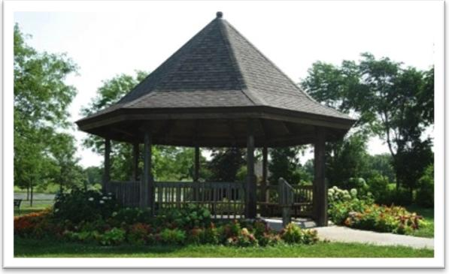

The City of ValparaisoÕs Zoning Plan was used as a resource to evaluate growth in, and adjacent to, the city limits. The map shown in Figure 5 (below) defines the planning area and the potential annexation areas adjacent to the City that form the basis for the Impact Zone related to this study.

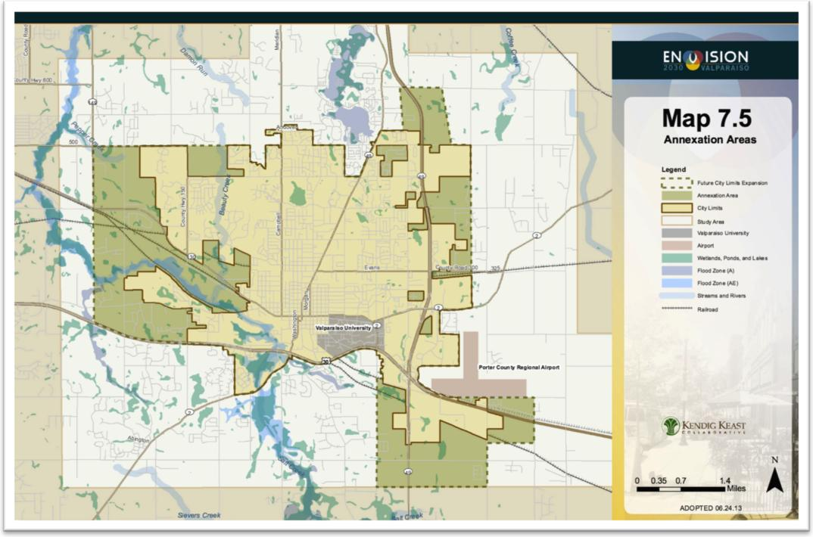
Figure 5 – City of Valparaiso Annexation Areas Plan (source: City of Valparaiso)
Parcel Growth by Development Population Projections
The Growth Model adopted by the Advisory Committee was termed Parcel Growth by Development Model. This model is based on the following:
- Acknowledgment of existing developments and growth projections within the current corporate limits
- Identification of land parcels within the current corporate limits of the City whose projected land use is residential development
- The City’s own growth strategies are factored into the growth model
- Growth will occur with stimulation of other developments and infrastructure
The analysis examined residential development capacities based on the actual densities of the planned development or the densities permitted in the City’s Zoning Ordinance. It is noted that the growth analysis scenarios used do not reflect the intentions of the existing landowners or the intention of the City regarding annexation.
The Consultant worked with the City and created an inventory of development parcels within the Comprehensive Plan’s Planning Boundaries; more particularly within the current Corporate Limits. Following the

Valparaiso Recreation Zone Improvement Plan Study
defined Future Land Use Plan, of the Comprehensive Plan, each residential development parcel had a development density (housing units per acre) applied to the parcel to determine what “build out” potential each parcel could carry. Besides the un-development parcels, existing developments that have not been completely built out were also inventoried for this growth analysis.
The Analysis process of this growth model involved the Consultant and City’s planning staff going through each of the un-developed parcels plus the existing developments and subdivisions to determine how much could be built out (by percentage) over the next ten years. By applying a different percentage to each parcel different scenarios of growth were generated.
For planning purposes the Consultant, Planning Staff and Advisory Committee analyzed the potential future populations of the City based on the Future Land Use Map and the known housing developments in and around the City. Land tract parcels were drawn on an aerial map (Figure 6) of the City and study area.
Figure 6 (below) illustrates the planning area and the residential growth potential for the City. This area covers the Impact Fee Zone of only the Planning Jurisdictional Limits of the City.
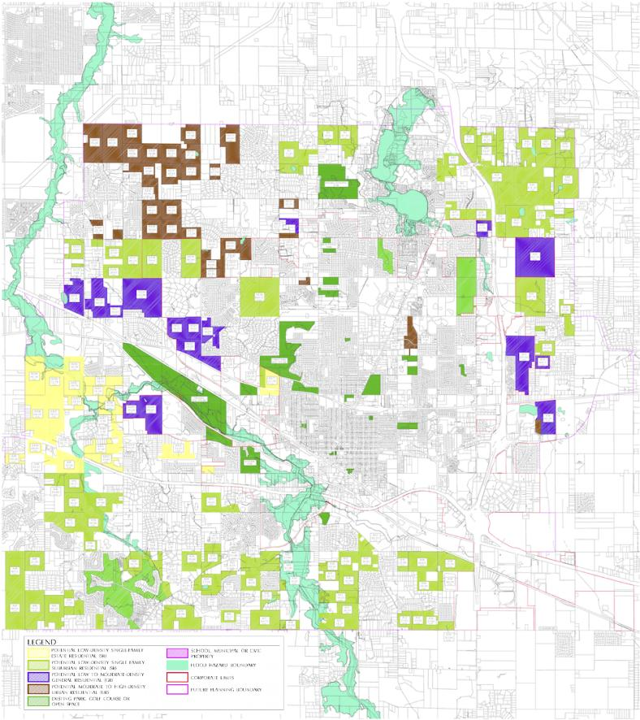 | Figure 6 – Valparaiso Residential Growth Potential (Only within the Planning  Jurisdictional Limits) Source: City of Valparaiso development resources and interactions with City Staff and Consultant (Larger version of the above map available at the City’s Planning Department.)

Valparaiso Recreation Zone Improvement Plan Study
Population Growth Potential of Planning Area
The following work sheets illustrate the residential growth potential. Table 1 identifies undeveloped land parcels, its acreage, land use zone, the parcels’ potential for residential units, and related populations. The City Planning Department provided a residential density base on the GIS information of existing residential developments in Valparaiso . Developable areas of each parcel were calculated with regard to flood plain and
typical site infrastructure areas (i.e., retention areas, street right of ways, etc.). The remaining columns identify the 10-year growth potential (as a percentage) and the relative number of residential units and populations.
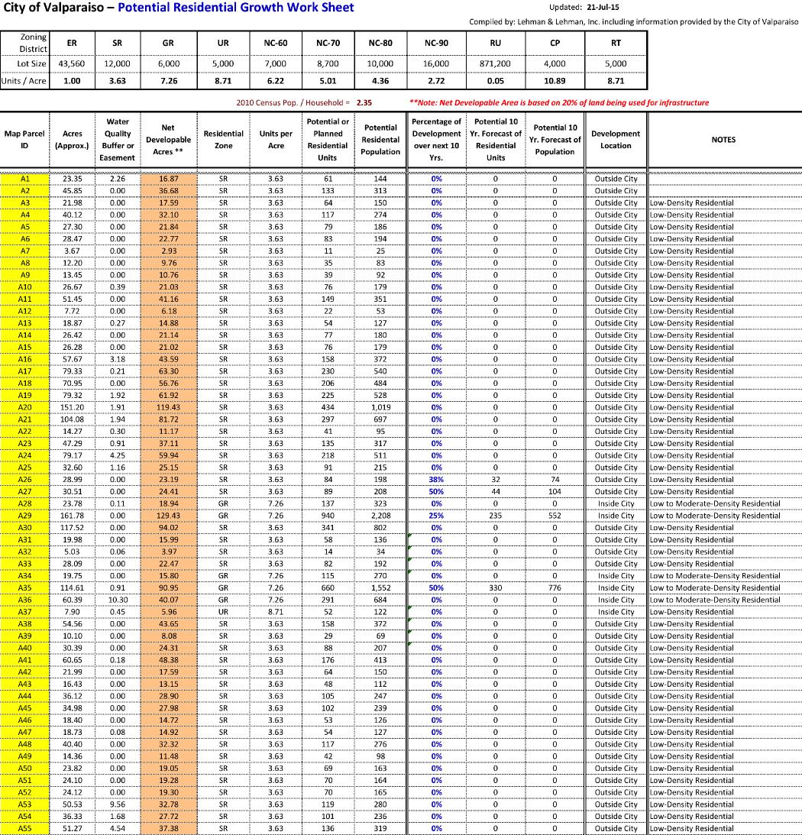

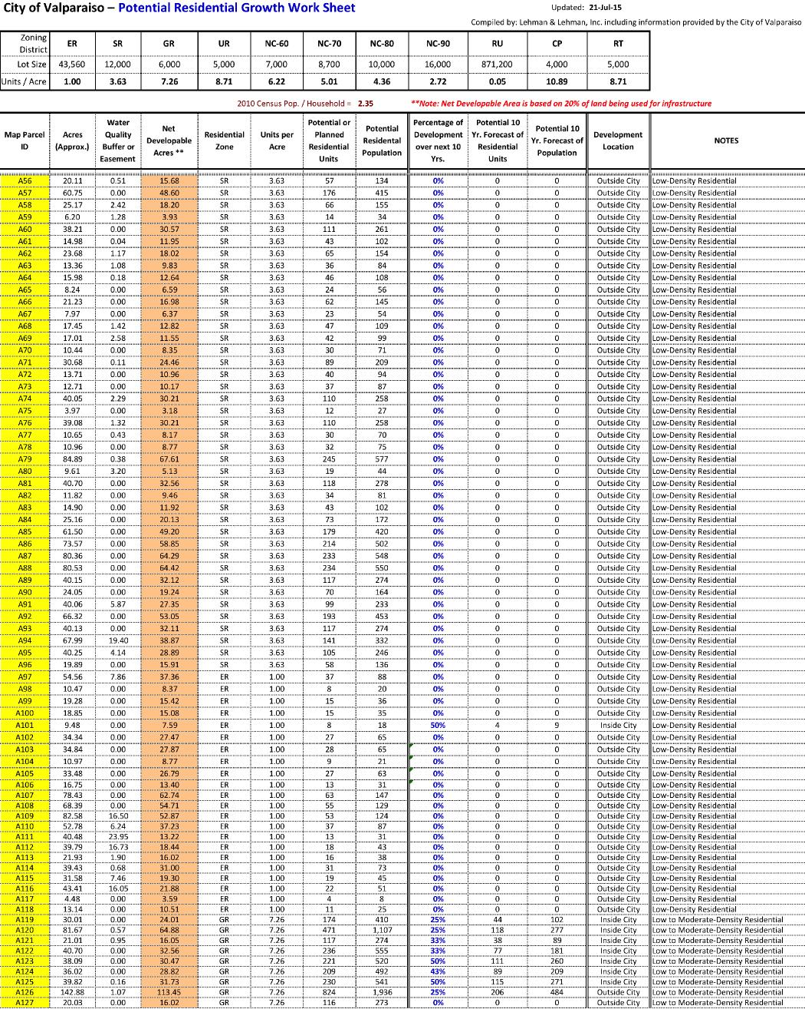

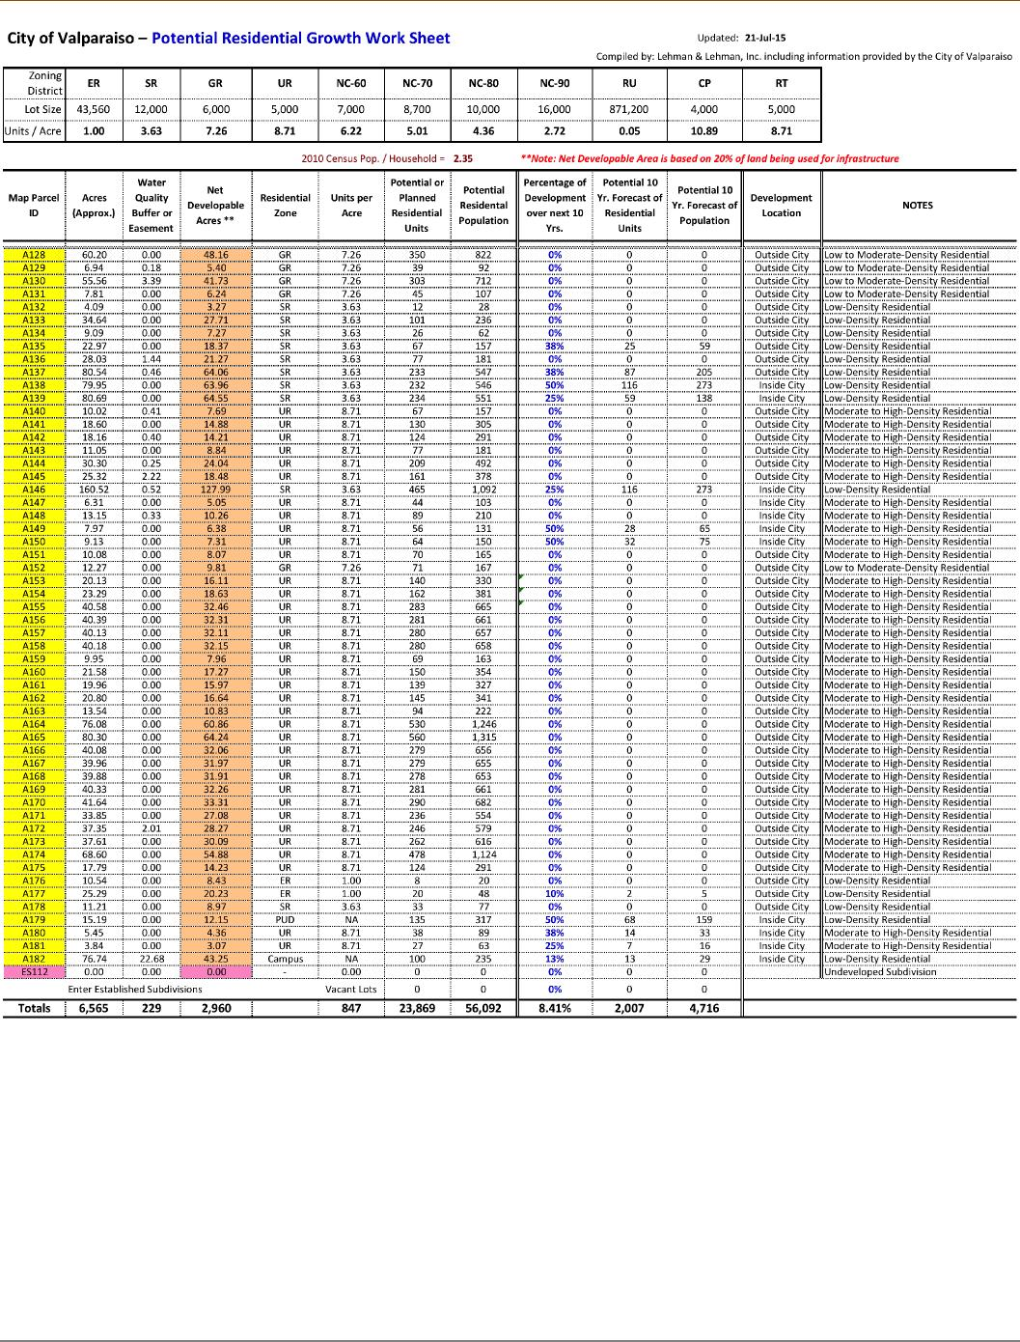
Table 1 – Valparaiso Potential Residential Growth Work Sheet of Undeveloped Land Parcels

Valparaiso Recreation Zone Improvement Plan Study
Similarly Table 2 identifies the existing, or planned residential developments within the City. These existing subdivisions currently contain vacant lots for development. The City provided this inventory information to the Consultant for inclusion with this analysis. In the same fashion as the analysis in Table 1 assumptions were made on these developments’ 10-year build out.
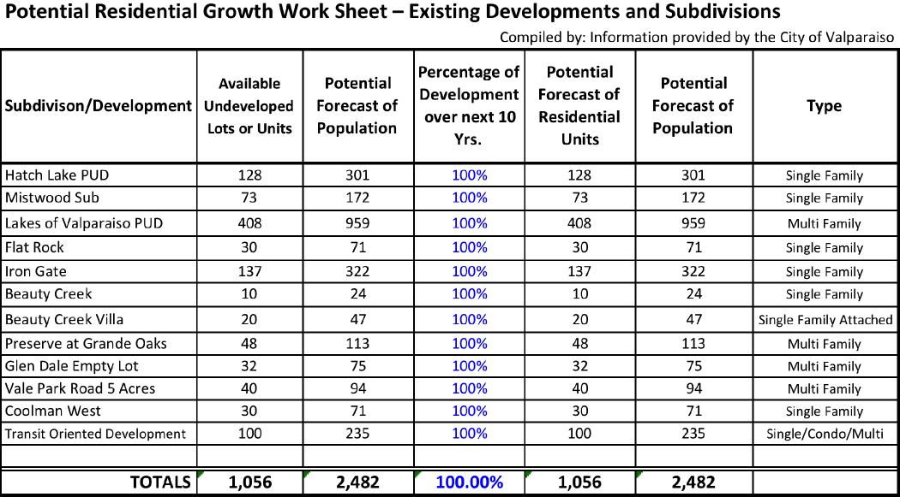
Table 2 – Valparaiso Potential Residential Growth Work Sheet of Existing Developments
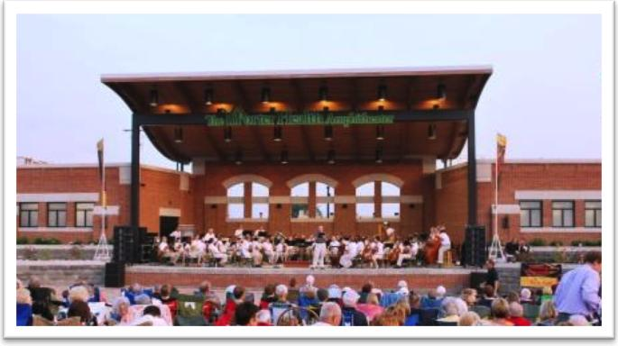

Valparaiso Recreation Zone Improvement Plan Study
Potential Residential Growth Summary Forecast
From the analysis and work sessions with the Planning Staff of the City the following is the projection of residential growth over the next 10 years. Also, it should be noted that the assumed population at the end of 2014 (32,986 persons) was factored by the Planning Staff and provided to the Consultant. The findings indicate that the City will grow by 7,198 by the year 2024 for a total population of 40,184. Table 3 below highlights this summary information.
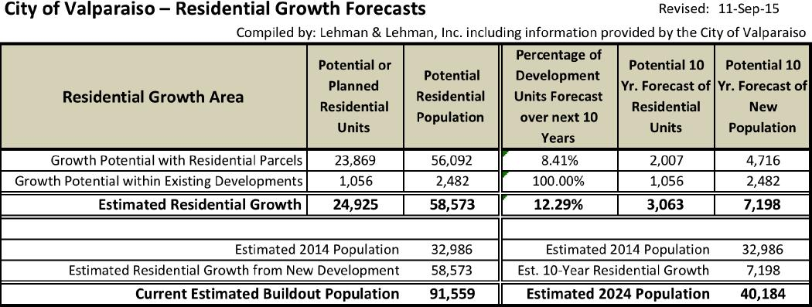
Table 3 – Potential Residential Growth Summary
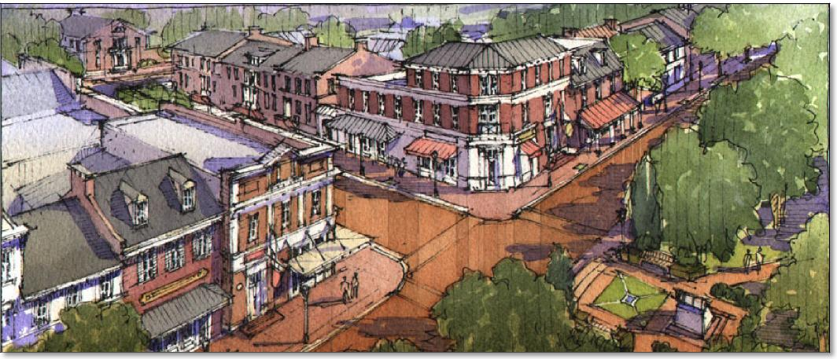

Valparaiso Recreation Zone Improvement Plan Study
Expectations of Population Growth /
Residential Building Permit Projections
From the previous analysis the population growth forecast over the next 10 years is tabulated in the following tables and includes projected new residential building permits applying the 2.35 persons per household established in 2010 Census. The following Table 4 illustrates the historical population growth over the previous decades and forecasts of population growth over the next 10-year period.
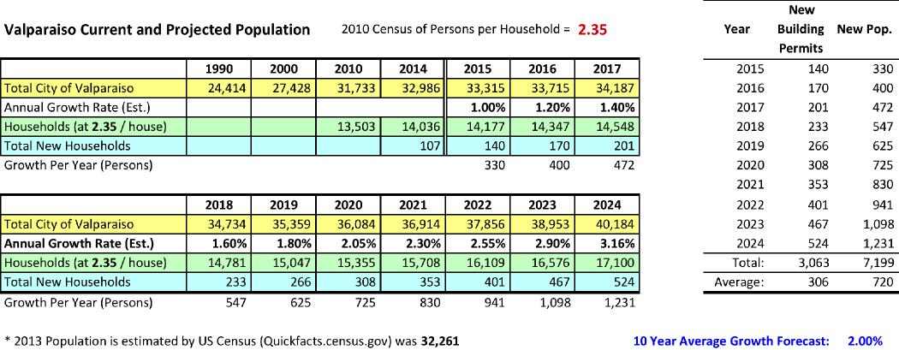
Table 4 – Current and Projected Population and Building Permit Growth
Included in the above table is a projected annual growth rate for the Impact Zone. This growth rate percentage factors in the relative flat growth the state, and country, is experiencing in the housing market. It does project an annual growth rate that best matches the growth strategies in the previous section of this study. The overall growth projection is 3,063 residential units (7,199 persons) with a ten-year growth rate of 2.00%. This growth assumes that other development infrastructure components (public utilities, roads, drainage, etc.) will be implemented in advance, or in conjunction with, the residential developments.
Note that since Recreation Impact Fees cannot be collected until six months after the ordinance is approved the revenue calculations for building permits will not include those projected in the six months after the ordinance approval.
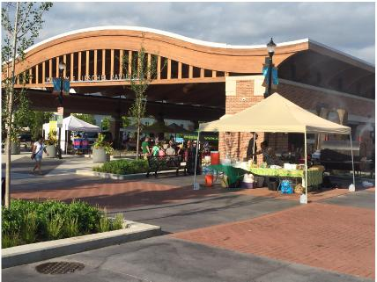

Valparaiso Recreation Zone Improvement Plan Study
Following is Figure 7 that illustrates the historical growth of the City and the projected growth over the coming ten years.
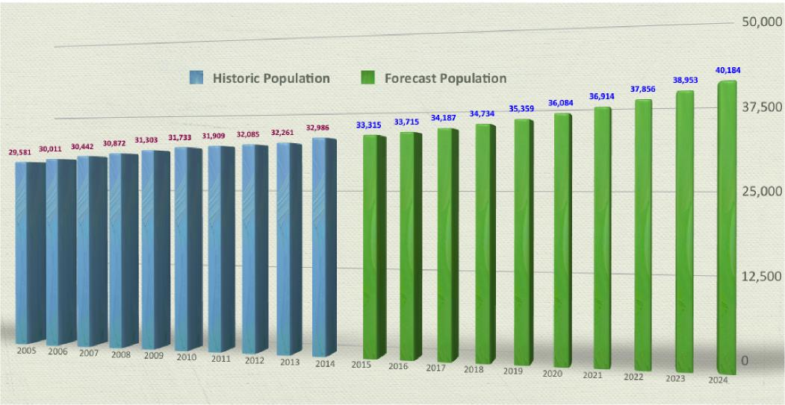
Figure 7 – Historic and Projected Population of the City of Valparaiso
Existing Park Land Facilities
Park Sites and Acreage Needed
Valparaiso’s Five Year Park Master Plan Update categorized parks as block, neighborhood, community or special parks, depending on the size of the park and the population that the park is intended to serve. The following definitions are consistent with those found in the current Park and Recreation Master Plan Update.
Definitions:
- Block Park – A small park located within residential areas that serves concentrated or limited population. Typical size is less than 5 acres of land.
- Neighborhood Park – An area that provides recreation opportunities within walking distance of residents. Typical size is between 5 and 50 acres of land.
- Community Park – An area that provides recreation opportunities for two or more neighborhoods. Typical size is between 51 and 400 acres of land.
- Special Park – An area that provides recreation resources and opportunities to all local communities as well as those within the local region. This park type could be a preservation area as well as linear trail and greenway system. Typical size is 100+ acres of land.

Valparaiso Recreation Zone Improvement Plan Study
Table 5, Park Site Inventory, provides an inventory of the parks, their acres, type and location within the existing impact zone.
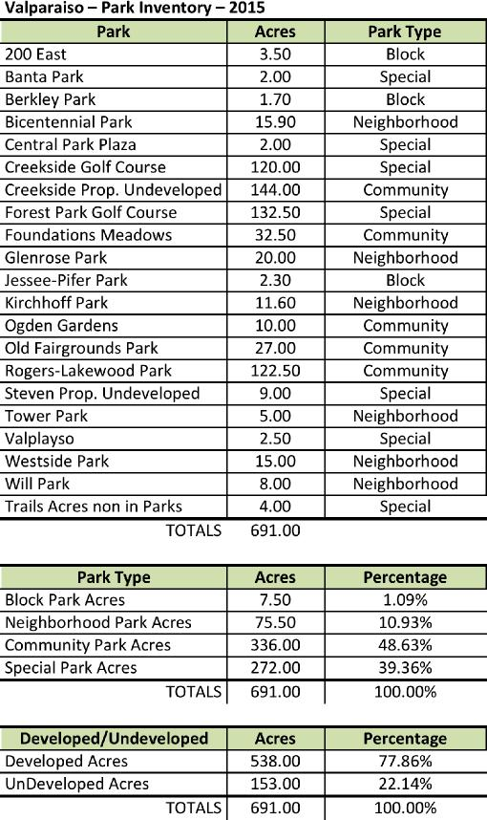
Table 5 – Park Site Inventory
There are standards that exist for the amount of acres of various park/open space lands for each of the above park types. A planning standard that was used in previous Master Plans was an acreage standard of 20.0 acres per 1,000 persons.
The total existing City park acreage (not including parks in existing subdivisions, open space on school properties) equals 691.00 acres. When applying the current population against the acreage inventory it calculates out to a current level of service of 20.74 acres per 1,000 persons.
The Advisory Committee recommended, for the purpose of this study, that the Valparaiso Community Level of Service for Park and Open Space land is established at 20.00 acres per 1,000 persons. The following Table 6 illustrates the surpluses and deficiencies of land for park and open space purposes for one Impact Zone. The bottom portion of the table indicates the Valparaiso Community Level of Service of 20.00 acres / 1,000. Based

on the current 2015 inventory and applying the 20.00 acres / 1,000 persons (the current 2015 population) there will be a surplus of 24.69 acres in 2015. Yet, in order to meet the standard for the projected population there will be a need for an additional 112.69 acres of park and open space in 2024.
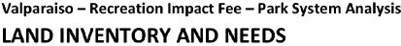
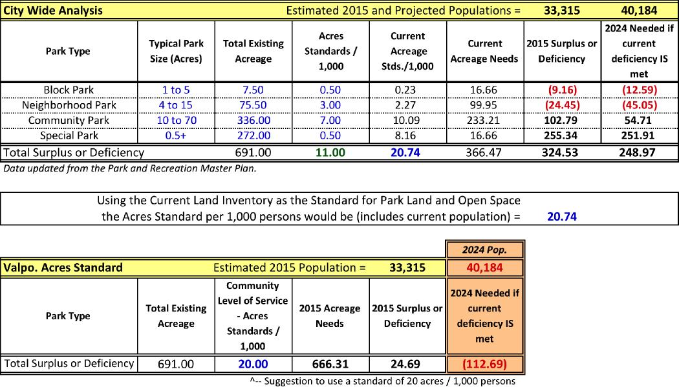
Table 6 Ð Land Inventory Ð Current Level of Service and Community Level of Service
Using the school sites to help meet future park needs will help to reduce both the total cost of the park system and the amount of the impact fee needed to help pay for the system. This strategy is also consistent with the fact that the City and the School District have worked cooperatively with each other, developing land jointly and sharing facilities whenever possible for the mutual benefit of the City and the School District. Such intergovernmental cooperation has led to the development of schools and parks adjacent to one another. In this way, for example, the same ball field might be used during school hours for physical education classes and during non-school hours for city -sponsored league play.
The City and the School Board should give consideration in the establishment of formal Memoranda of Understanding for shared uses of sites and facilities for each entity’s programming and public use. This will have a significant impact on the community levels of service for the Valparaiso ’s community.
It is also important to note that in order to satisfy requirements in the State impact fee legislation, the City would not be able to use money collected from the proposed impact fee to help pay for acreage needed to overcome a current deficiency. With respect to land acquisition, money generated by the impact fee can be used only toward acquiring the various acreage needed to meet the deficiencies resulting from projected population growth.

Existing Infrastructure of Recreation Facilities
Park Facilities and Current Level of Service
In order to know whether existing park and recreation facilities are adequate to meet the needs of the current population, the City established standards for the amount of various types of facilities needed to serve a given amount of population. The desirable local standards for the various types of facilities are stated in the column titled “Valparaiso Community Level of Service” in the following tables.
For example, the City has established a standard for multi purpose fields that calls for one (1) multi purpose fields for every 8,000 persons. Refinements were given on the standards for each recreation facility component from that of the previous Master Plan Update and Recreation Impact Fee studies. The inventory of recreation components found within the Park System and those found in the community as a whole can be found in Appendix E: Park and Recreation Infrastructure Inventory.
In tallying the recreation facilities the Advisory Committee included both the facilities of the Valparaiso Parks and Recreation as well as those other recreation facilities serving the public found within the community. These two inventories are tallied and included in Table 7 [IC 36-7-4-1318 (b)(2)]. The recreation facility standards were updated from the previous five-year master plan. New standards were established for the additional recreation facilities added to this list. State and/or National standards were used as a reference but much analysis was done as to the current inventory and the community needs for each of the facilities.
The application of the local standard to the current population enables the current need to be established and surpluses or deficiencies calculated. The various columns in the top of Table 7 show:
- The recreation facility component being considered (Column A)
- The standard for the number of persons that each facility should serve (Column B)
- Total existing number of each type of recreational facility (baseball fields, softball fields, basketball courts, tennis courts, etc.) in both the Park System as well as in the community (Columns E and F)
- The needed number of each facility type based on application of the standard to the present population (Column H)
- The surplus or deficiency of each facility relative to current p opulation, based on the applicable standard (Column J)
For example, referring to soccer fields in Table 7, there are nine (9) soccer fields as part of the Park System (Column E) and an additional two (2) soccer fields in the community (Column F). In meeting the current Community Level of Service the City should have 16.66 soccer fields (Column H). If you applied only the park system’s inventory there would be a deficiency of 7.66 soccer fields. Yet there is a total of 11 soccer fields that exist in the community (adding together the park system and the community inventories – Column G). This analysis will be important in applying priorities to each of the recreation components.
The Consultant worked with the Park Staff in establishing priorities of recreation components. These priorities were established based on the Park Department’s perception, user feedback from master planning process, community surveys, etc. along with which components might best benefit in the inclusion of the Recreation Impact Fees. The priority ranking was “A”-Top Priority, “B”-High Priority, and “C”-Low Priority. The Advisory Committee and Park Department selected six (6) infrastructure components as the “A” priorities. Those priorities are illustrated in the tan lines in the following table.

Valparaiso Recreation Zone Improvement Plan Study
The following Table 7 represents the Facility Inventory and Needs projections for the current and future populations. This table is the inventory and needs for the Impact Zone and it indicates the Valparaiso Recreation Standards, the current number of facility components, the needed component number based on both current and future populations and the surplus or deficiency of the recreation component. This table also includes the park land (acres) component.
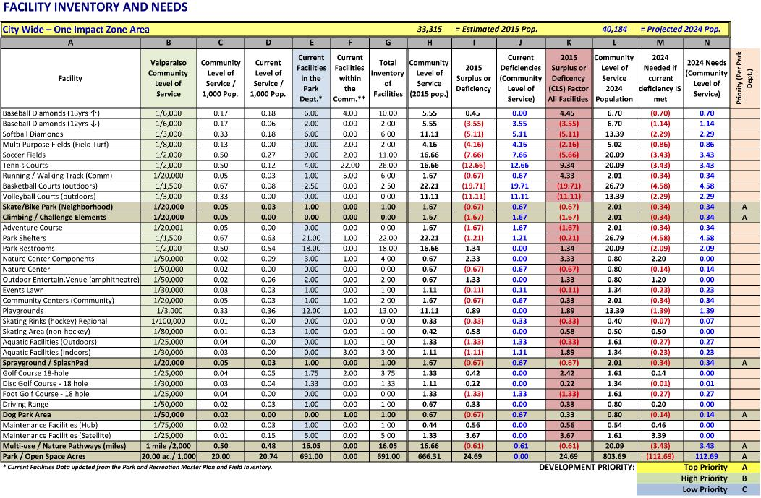
Table 7 – Facilities Inventory and Needs
The Advisory Committee reviewed and established new standards, or Community Level of Service, to reflect the desired needs of the various recreational infrastructure components. These standards are based on current assumptions of the needs of the community so they need to be reviewed annually by the Park Board. Current facilities not part of the Park System but found within the zone were
also noted. Many of these non-park system
components serve a need in the level of service. Therefore, the standards used reflect the impact of all recreation infrastructure components to the level of service found within the community. Again, only the inventory of the Park System was used in determining the current deficiencies and future needs reflected in the Recreation Impact Fee analysis.
As was suggested with the park land inventory, it is again recommended that the City, the School Board and other recreation providers give consideration in the establishment of formal Memoranda of Understanding for shared uses of sites and facilities for each entity’s programming and public use. This will have a significant impact on the community levels of service for the Valparaiso’s community.
For the purposes of this study analysis the current and future needs and their related costs were leveraged using the prioritized recreation components.

Park Facilities – Community Level of Service [37-7-4-1318 (b)(3)] Summary of Park Facilities Analysis
The number and types of recreational facilities needed currently and in the future were determined using the standards established earlier in the plan and applied to only those components found within the Park System. To overcome current deficiencies the City needs to add the recreation components listed under current deficiencies over the next ten-year period through funding outside of Recreation Impact Fees. (Note the recreation components have been arranged by priority.)
To meet the 2024 projected growth and factoring in that the current deficiencies will be met, the City will need to add to its Park System the recreation components listed under future needs over the next ten-year period, using RIF proceeds. (Note the components have been listed in priority groupings in Table 8.)
Current Deficiencies and Future Needs

Table 8 – Current  Deficiencies and  Future Needs | 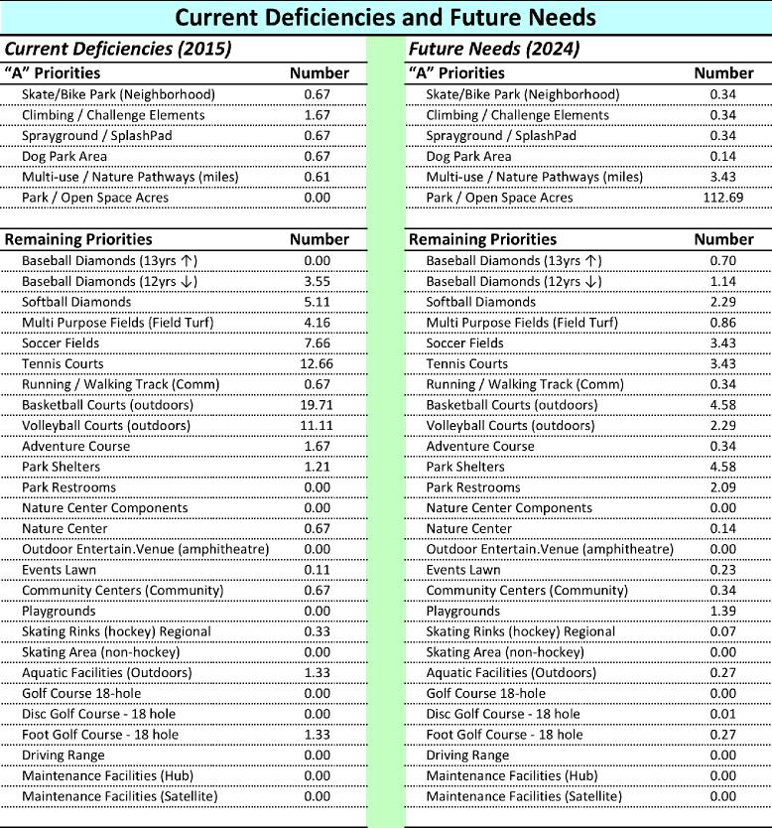

Valparaiso Recreation Zone Improvement Plan Study
Acreage Needed for New Facilities – Community Level of Service
The new recreation components that will fill both the current deficiencies and future needs will require land area for their development. Keep in mind that the new components can be sited within existing park land as well as in new park land. The following table (Table 9) indicates the approximate acreage required for each of the deficient recreation components in one Impact Zone. In addition, the prioritized groupings of the recreation components have been summarized at the bottom of the table.
When applying the size needs for all of the recreation components the current deficiencies will require approximately 121.73 acres (5.46 acres of “A ” Priorities not including the land component). The future needs for all of the recreation components will require approximately 57.22 acres (not including the future need of 112.69 acres) with 16.55 acres of “A” Priorities. (Note: the purpose of this table is to illustrate the amount of land space required to accommodate the recreation facility. Thus the reason for not including the land component in the totals).
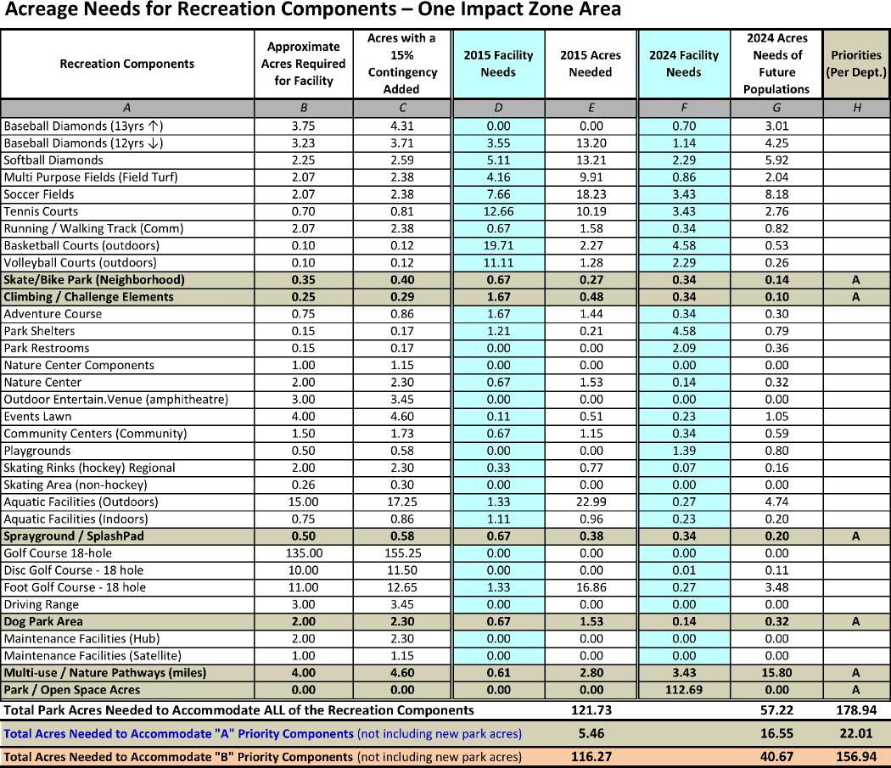
Table 9 – Acreage Needs for Recreation Components

Community Level of Service Needs
and Cost Estimates
The cost estimates of the recreational amenities required to overcome both the current deficiencies and future needs were estimated by establishing facility costs for each of the recreation components. The information in Table 10 illustrates the estimated costs required for both the current deficiencies and future needs. Note, the tan shaded lines are the recommended “A” priorities to be applied to the recreation impact fee calculations. Again, remember that current deficiencies cannot use Recreation Impact Fee resources, whereas future needs can use Impact Fees resources.
Facility Needs – Costs for One Impact Zone
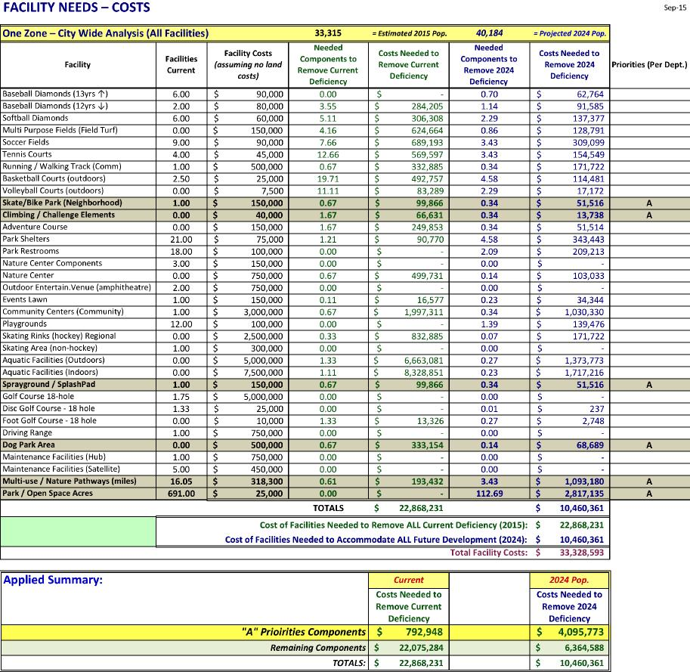
Table 10 – Cost of Recreation Components to Overcome Current Deficiencies and Future Needs

Valparaiso Recreation Zone Improvement Plan Study

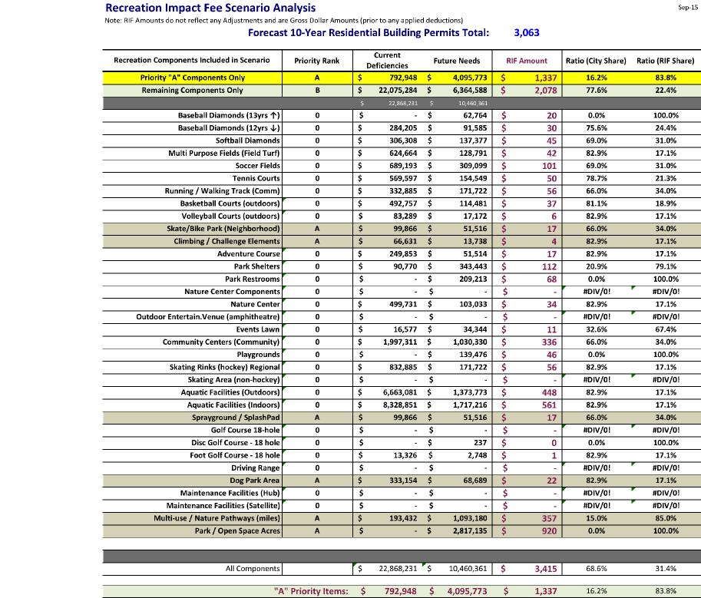
Table 11 – Recreation Impact Fee
Scenarios
The component cost estimates were based on current construction estimates and those of actual projects. They are broad estimates at this point in time since there are many variables to consider. The current (2015) deficiencies (raising Current Level of Service to Community Level Service) for ALL recreation facilities total $22,868,231 and if included in the RIF calculations would need to be completed within the next ten years (2024).
The component cost estimates for future (2024) needs, including ALL of the recreation components, total $10,460,361. Costs for ALL current deficiencies AND future recreation facility needs total $33,328,593. In the same manner the Prioritized Groupings were summarized at the bottom of the previous table. The current deficiencies (2015) for the “A ” Priorities would be $792,948. The “A” Priority components cost estimates for the future (2024) needs would be $ 4,095,773.
Recreation Impact Fee Scenario
The Advisory Committee and the Consultant looked at various scenarios created by selection and combinations of components. Table 11 lists each scenario and its current deficiency dollar amount and its future need dollar amount. The table then lists what the impact fee amount would be for each identified scenario. This calculation applies the total 10 -year projected residential building permits (3,063 residential building permits) into the costs of the recreation components to determine a “gross” Recreation Impact Fee amount (without any applied deductions). The last two columns of Table 11 show the ratio of the current deficiencies (what the City will be responsible for outside of RIF dollars) and the future needs (or available RIF dollars).

Valparaiso Recreation Zone Improvement Plan Study
Table 12 provides a summary of the Applied Recreation Components (“A” Priorities) that will be applied in the Recreation Impact Fee calculations.
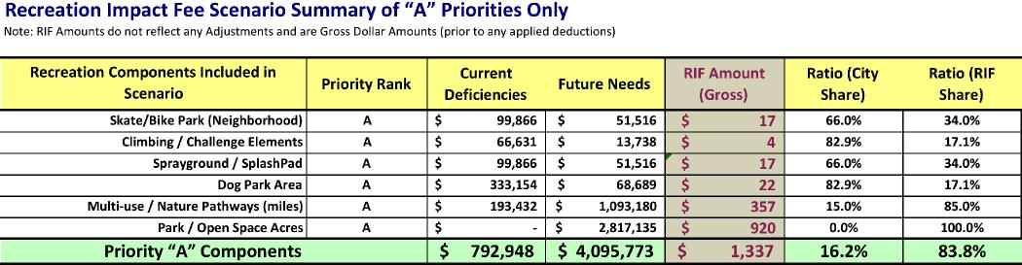
Table 12 – Recreation Impact Fee Scenario Summary of “A” Priorities
Recommended Recreation Impact Fee
Funding for Current Deficiencies Based on Community Level of Service [IC 36-7-4-1318(c)(3)]
Again, Recreation Impact Fees cannot be used to cover the costs of identified current deficiencies. The noted current deficient recreation components have been listed in Table 13 along with each project’s funding sources and projected cost budget.
The current deficiencies of the selected “A” Priority components total $792,948. The Consultant worked with the Park Administrative Staff and Advisory Committee regarding the various funding sources that could be used to fund the current deficiencies. It was determined that the City acknowledges current deficiencies and their related costs and strategically focus on the funding of the deficiencies over the next 10 years. Table 13 outlines the funding sources and their applied distribution. The funding sources and their related percentage of distribution include: Grants and Other (2.52%), Park Capital Improvement Budget (20.14%), City Tax Increment Fund (TIF) (24.39%), City Cumulative Capital Funds (25.22%), Donations (16.39%) and Other (11.32%). Additional funding sources are not anticipated at this time.

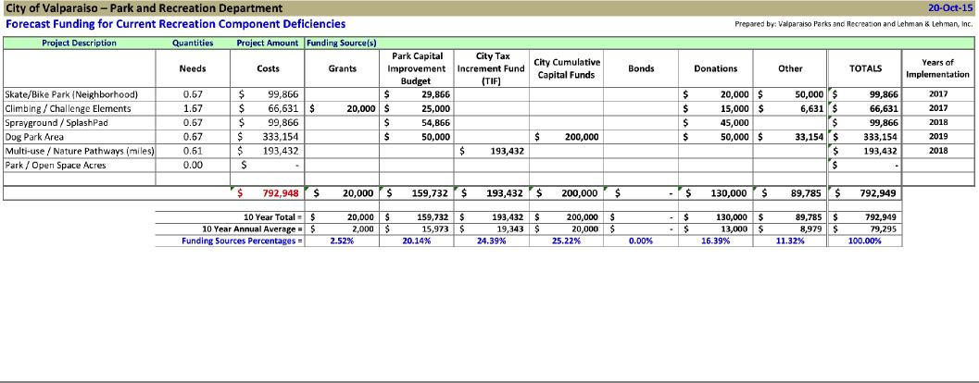
Table 13 – Funding Sources for Current Deficiencies

Valparaiso Recreation Zone Improvement Plan Study
Analysis of Non-Local Revenue and Impact Deductions
Following IC 36-7-4-1321 the Recreation Impact Fee Formula is as follows:
Recreation Impact Fee =
Impact Costs Ð Non-Local Revenues Ð Impact Deductions / 10-Yr. Residential Building Permits
- Impact Costs = Cost estimate [made at time of study] needed to fund projected future infrastructure needs of the next 10-year period
- Non-Local Revenue = Reasonable estimate [made at time of study] of revenues that will be received from any source other than a governmental source that will be used in the Impact Zone
- Impact Deduction = Reasonable estimate [made at time of study] of revenues from taxes levied and charges & fees that will be paid during the 10-year period after assessment of the impact fee to defray the capital costs of providing infrastructure in the Impact Zone
- 10-Year Building Permits = Forecast of residential building permits projected in the next ten year period
Non-Local Revenue Deductions
It was determined in the analysis and work with the City there would be “Non-Local Revenues” anticipated to be used to cover the current deficiencies. As noted in Table 13 it is anticipated that there would be approximately $130,000 in donations towards current deficiencies.
Impact Deductions
Recreation Impact Fees cannot be used to fund current deficiencies. From Table 13, six funding sources are noted for the current deficiencies. Those funding sources include Grants, TIF, Donations and Other. These funding sources have limited roots to property taxes and other residential sources. However the remaining funding sources (Park Capital Improvement Budget and City Cumulative Capital Funds) are funding sources that come from property taxes and other residential sources. Table 13 outlines the disbursements of the funds on an annual basis as defined by the implementation year noted in Table 14.
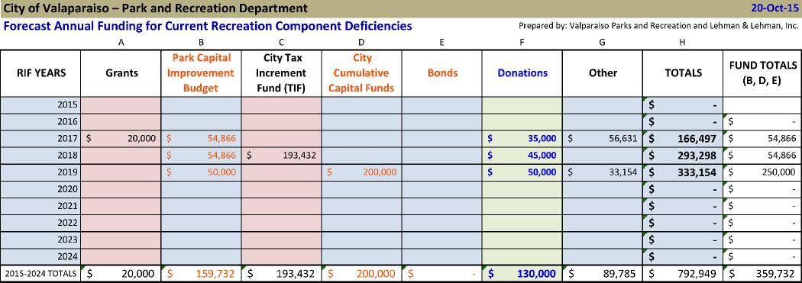
Table 14 – Forecast Annual Funding for Current Deficiencies

Valparaiso Recreation Zone Improvement Plan Study
The impact of these funding sources will be based on the number of households within the City. The following Table 15 establishes the cumulative households (column A) of the city over the next 10 years with the projected growth of households each year as noted in column B. The cumulative of the new household growth is noted in column C. The costs that affect residential property tax of the current deficiency for the next 10 years is noted in column D. The table indicates the calculated amounts of the funding of current deficiency per household (columns E, G, and H). The totals of those three columns are multiplied by the cumulative New Households (col. D) to determine the impact deductions for each year of the 10-year RIF period as noted in column I. The total Impact Deduction amount is determined to be $21,474.
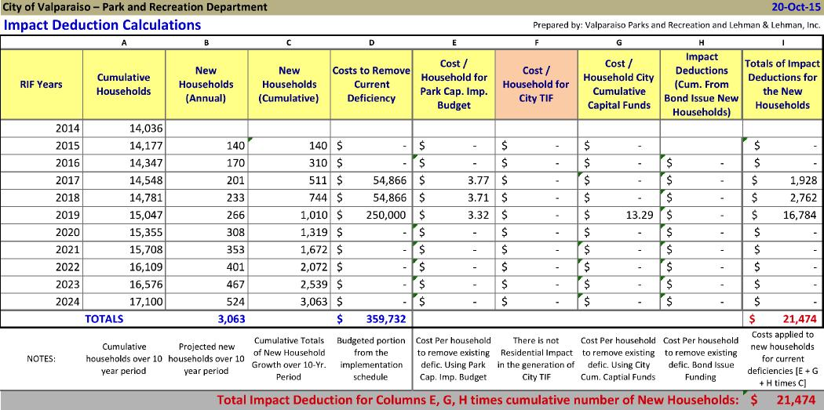
Table 15 Ð Impact Deduction Calculations
Following IC 36-7-4-1321 the Re creation Impact Fee Formula is as follows:
Recreation Impact Fee =
(Impact Costs) Ð (Non-Local Revenues) Ð (Impact Deductions) / (10-Yr. Bldg. Permits)
Table 16 shows the pre-adjustment quantities and their costs of the Future Needs components and the post-adjusted of the same after applying the non-local revenues and impact deductions. The total deficiency costs used in the RIF calculations was adjusted to be $3,944,299.
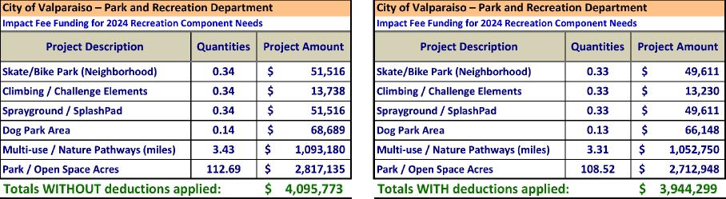
Table 16 Ð Future Need Recreation Components and their Costs

Valparaiso Recreation Zone Improvement Plan Study
As shown in Table 16 the total estimated cost of improvements (“A” Priorities) needed to accommodate projected future growth is $3,944,299 (adjusted Impact Costs which include the Impact Deductions of $21,474 and Non-Local Revenues of $130,000). Therefore, the Recreation Impact Fee is calculated as indicated in Table 17. Using this formula the result is a recommended Impact Fee of $1,288.
This recommended Recreation Impact Fee assumes that there will be a growth in housing permits at an average of 306 units per year over the next ten years (2015-2024). Future recreation facility needs will be funded using the suggested Recreation Impact Fee of $1,288. There will be the need to perform an update to this recreation impact fee study by or before 2018.
As previous RIF Ordinances have been defined there are Housing Equivalent adjustments that have been used (as illustrated at the bottom of Table 17. It was felt by the Advisory Committee that these equivalent percentages be handled on a case by case basis.
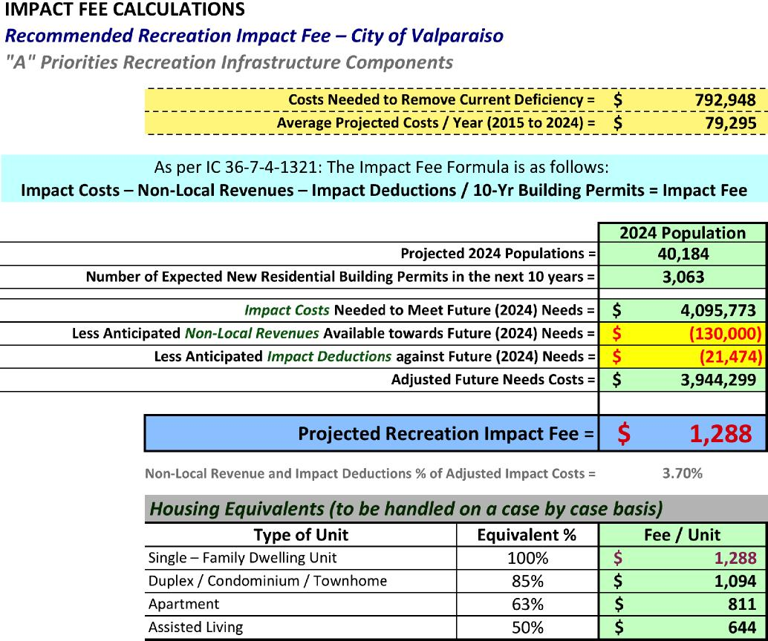
Table 17 – Recommended Recreation Impact Fee Calculations

Valparaiso Recreation Zone Improvement Plan Study
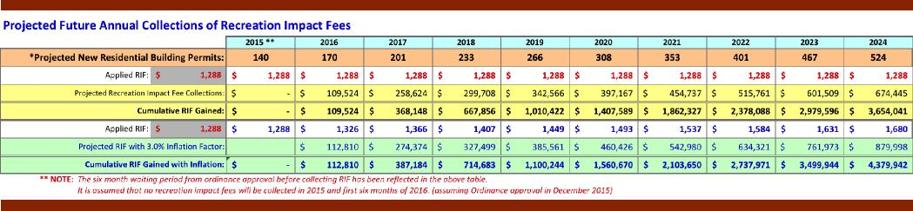
Annual Inflationary Adjustments
In order to keep pace with the increase of construction costs several other communities have adopted their Recreation Impact Fee Ordinance with a stepped increase over the ten-year period. Other communities have adopted an annual inflationary adjustment. This will need to be determined if the City of Valparaiso desires to include annual adjustments to their new ordinance . The Advisory Committee did not have a recommendation on this matter. Tabl e 18 and Figure 8 illustrate the projected revenue for Recreation Impact Fees with and without the inflation factor applied. A flat inflationary percentage could be used for this adjustment or annual adjustments could be made using a Gross Domestic Product (GDP) factor.
Annual Revenue Forecasts
The collection of Recreation Impact Fee revenues cannot begin until six (6) months after the approval of the ordinance by the City. Assuming that the City Council will approval the RIF ordinance in December 2015 the six-month period will end in June 2016. Based on this there will not be any RIF collection during the remainder of 2015 and the first six months of 2016. The current RIF ordinance will be expiring up to the time this new ordinance becomes activated. Table 18 and Figure 8 reflect this analysis.
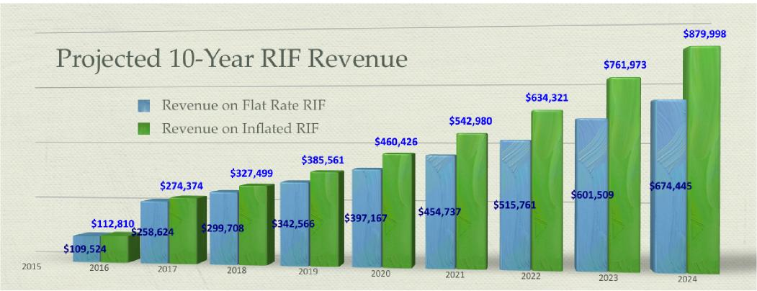
Figure 8 – Recreation Impact Fee Revenues Graph
Table 18 – Recreation Impact Fee Revenue Calculations

Valparaiso Recreation Zone Improvement Plan Study
Donations or In Lieu Of Impact Fee Components
As is being experienced in other communities that have Recreation Impact Fee ordinances, residential developers sometimes prefer to have the option to develop noted recreation components themselves and receive credit against impact fee charges. It was felt that both the multi-use trails and the land/open space are components where credit against Recreation Impact Fees could be considered. The City will need to develop the policy for such credit considerations.
National Averages of Recreation Impact Fees
The firm of Clancy Mullen, Duncan Associates annually tracks Impact Fees throughout the country. Their 2012 National Impact Fee Survey results serve only as a reference to this study. The averages of the 2012 survey found the following:
¥ Average Recreation Impact Fees of 271 municipalities | $2,774
Recreation Impact Fee Statistics – State of Indiana
Current Recreation Impact Fees of the noted municipalities (with ordinance dates noted).
• City of Greenfield (ordinance updated in 2014) | $1,153
¥ City of Valparaiso (ordinance updated in 2010) | $974
¥ City of Carmel (current ordina nce, 201 3) | $1,526
¥ City of Fishers (ordinance, 2006) | $1,070
¥ City of Franklin (ordinance, 2005) | $870
¥ City of Westfield (updated ordinance, 2013) | $1,309
¥ Town of Plainfield (updated ordinance, 2012) | $730
¥ Town of Cicero (updated ordinance, 2012 ) | $843
¥ Town of St. John (ordinance, 2013) | $1,736
¥ Town of Chesterton (ordinance, 2014) | $889
¥ Town of Brownsburg (updated ordinance, 2013) | $998
¥ City of Noblesville (ordinance, 2014) | $1,718
¥ City of Greenwood (ordinance 2015) | $1,206
¥ Town of Avon (ordinance established in 2012) | $987
¥ Average Recreation Impact Fees of the above noted communities | $1,143
¥ Proposed Recreation Impact Fee for City of Valparaiso (2015) | $1,288

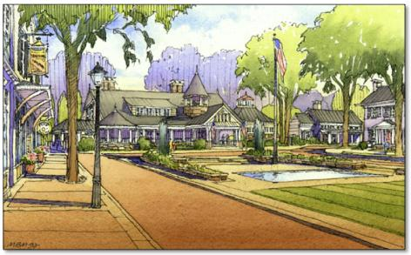

Implementation Schedule – For Raising Current Deficiencies to Community Level of Service [IC 36-7-4-1318(c)(1)(2)]
The following Table (Table 19) represents a tentative implementation schedule to meet the baseline of service for the identified current deficiencies. At the bottom of this table is a summary of all recreation components. Only the recreation components related and factored into the Recreation Impact Fee are summarized on an annual basis.
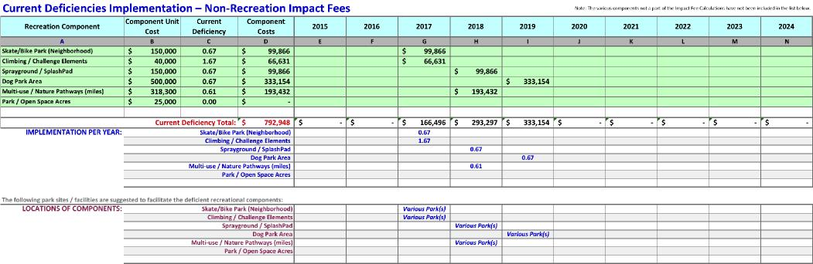
Table 19 – Implementation Schedule for Current Deficiencies
The Advisory Committee recommends that the 10-year implementation schedule begin in 2016. The implementation of the various recreation components will be throughout the 10-year period. The implementation of the various components will be throughout the 10-year period. The location of the components will be determined by the Park Department based on need.
Implementation Schedule – Future Anticipated Needs Based on Community Level of Service [IC 36-7-4-1318(b)(4)(5)]
The following Table (Table 20) represents a tentative implementation schedule to meet the baseline of service for the identified future needs. These needs are fundable via Recreation Impact Fees.

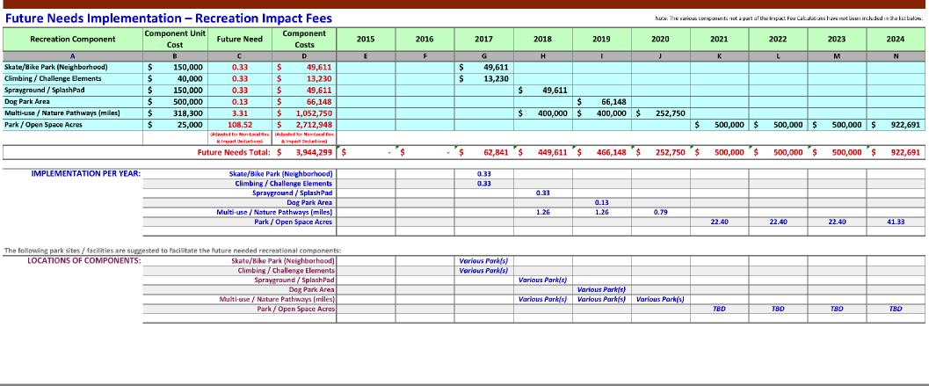
Table 20 – Implementation Schedule for Future Needs

Valparaiso Recreation Zone Improvement Plan Study
The Advisory Committee recommends that the implementation for future needs be done starting in 2016 and continuing through 2024. The implementation of the various recreation components is suggested over the 10- year period. The funding resource for these future need items will come from the collected Recreation Impact Fees. The implementation of the various infrastructure components will be based on the available funds from the collected recreation impact fees. The location of the various components will be determined by the Park Department based on need.
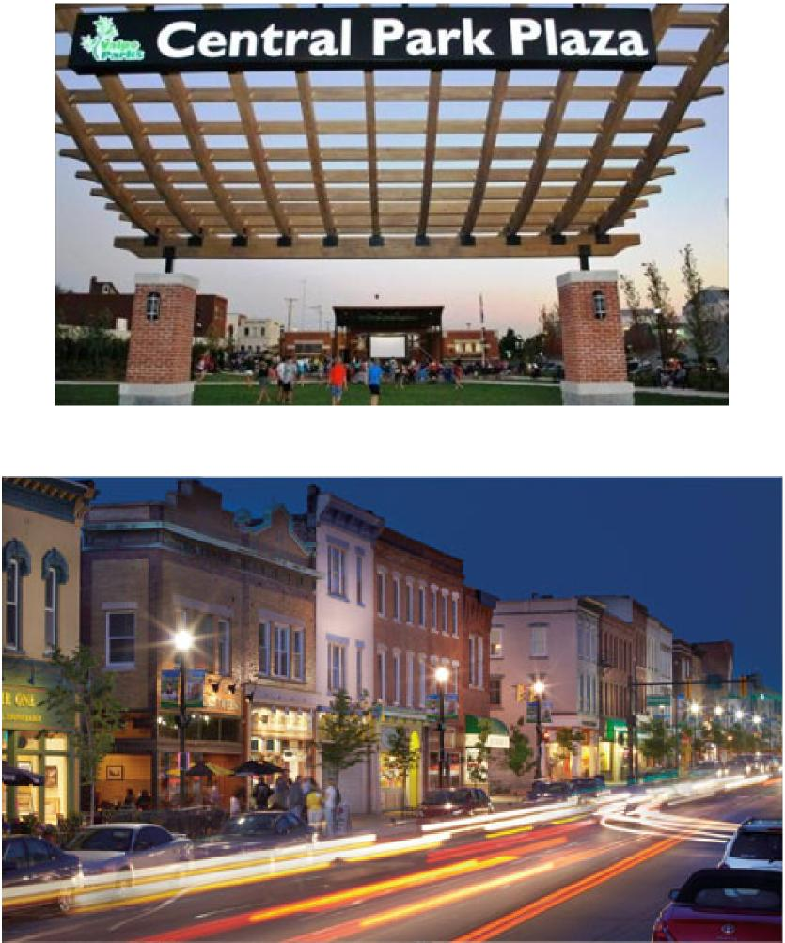

Summary of Impact Fee Study
The following previously illustrated tables summarize the inventory, need analysis, and cost projections for this study.
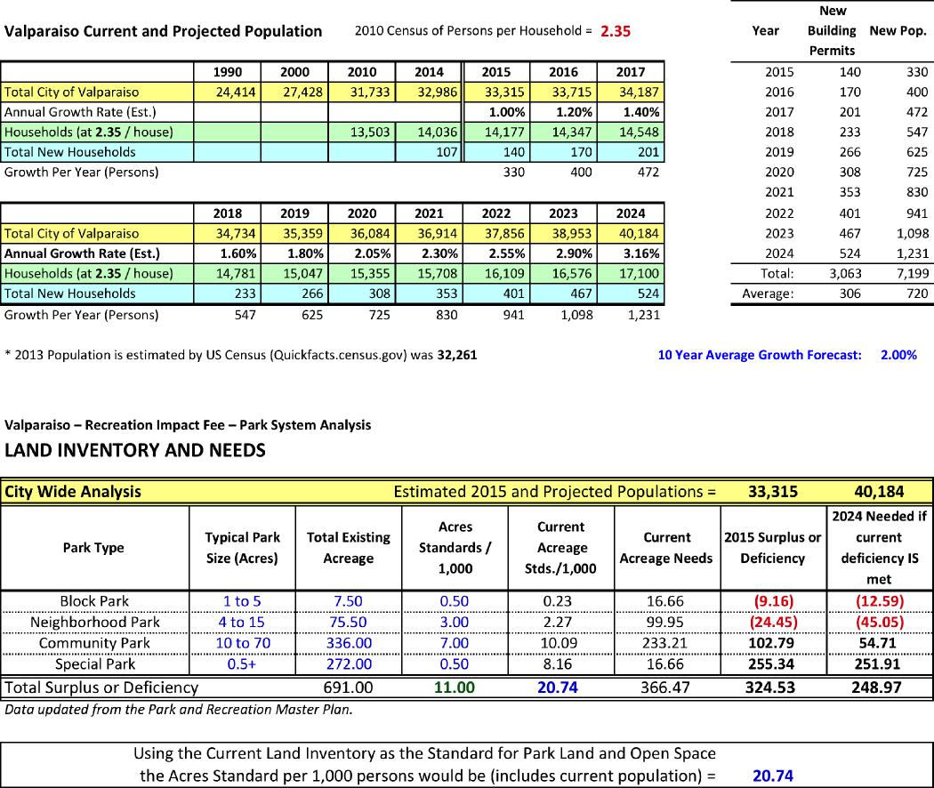
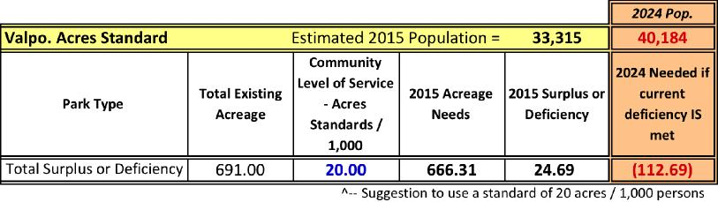

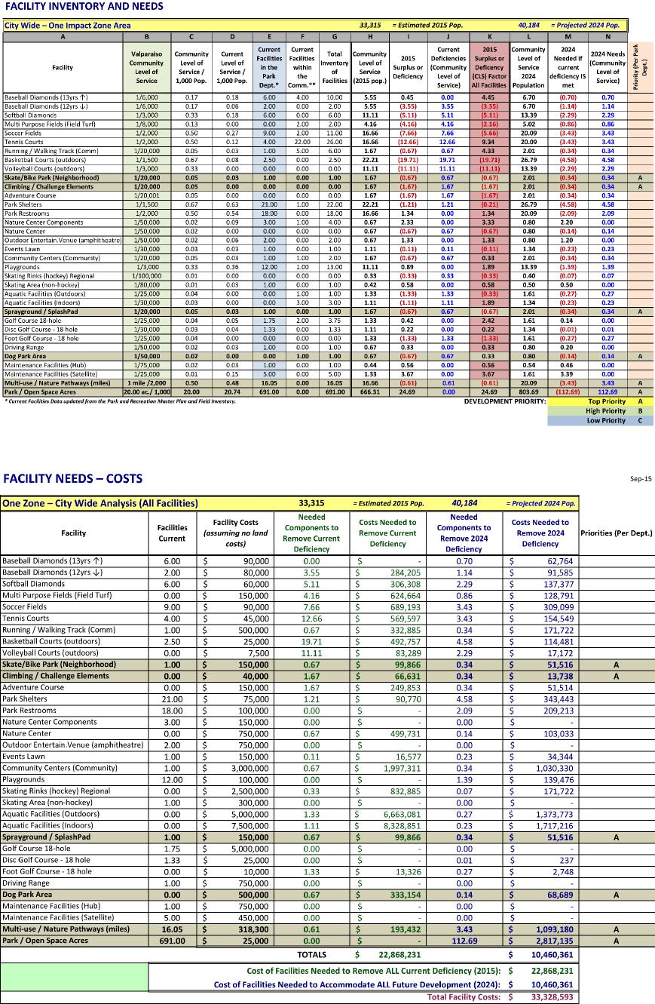

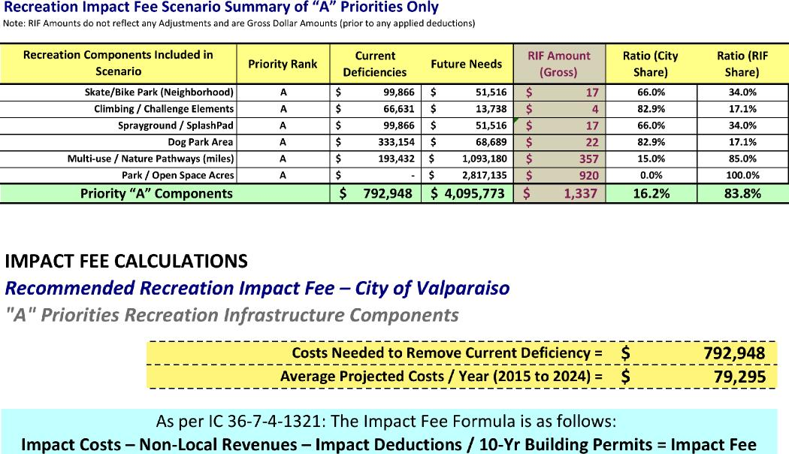
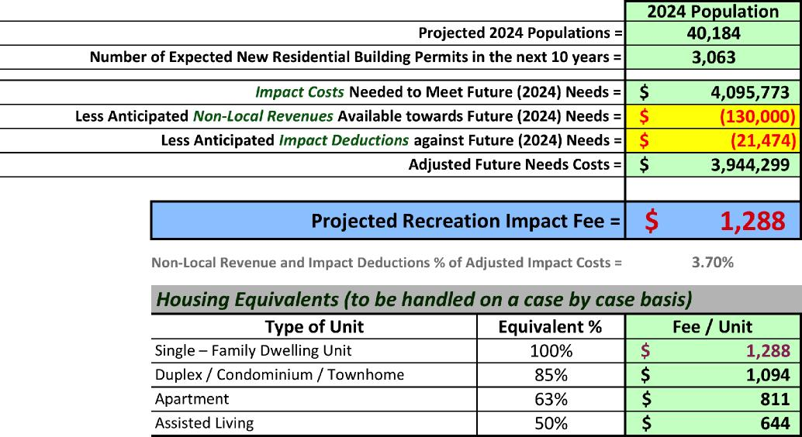

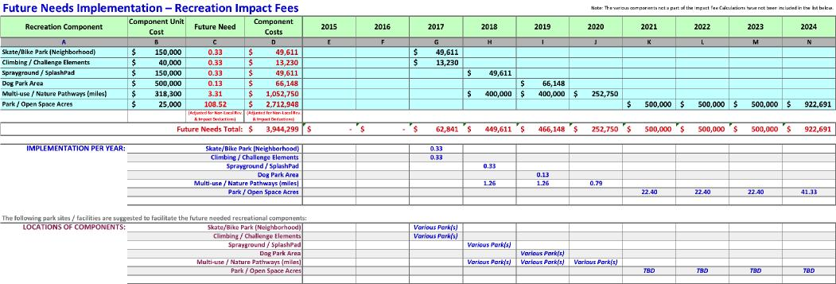
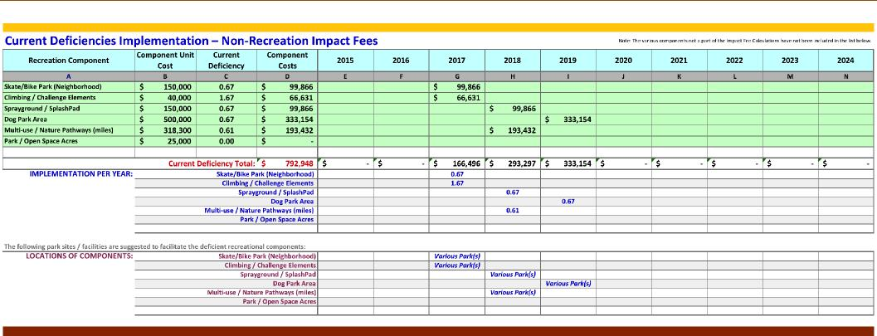
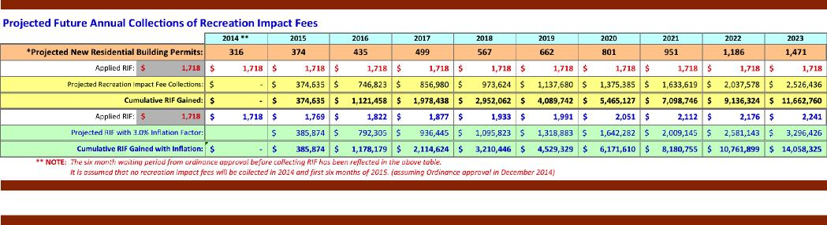
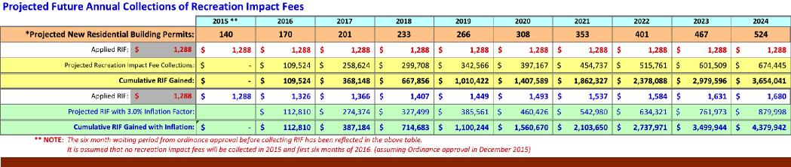

Appendix
- Appendix A: Indiana Code (IC) 36-7-4-1300
- Appendix B: Fixed Assets / Capital Improvements over the years 2010-2014
- Appendix C: Summary of Valparaiso Park Department Revenues 2009-2014
- Appendix D: Impact Fee One Zone Recommendation Logic
- Appendix E: Park and Recreation Infrastructure Inventory
- Appendix F: RIF Collections and Disbursements 2005 to 2014
- Appendix G: Letter of Study Review from Reviewing Professional Engineer
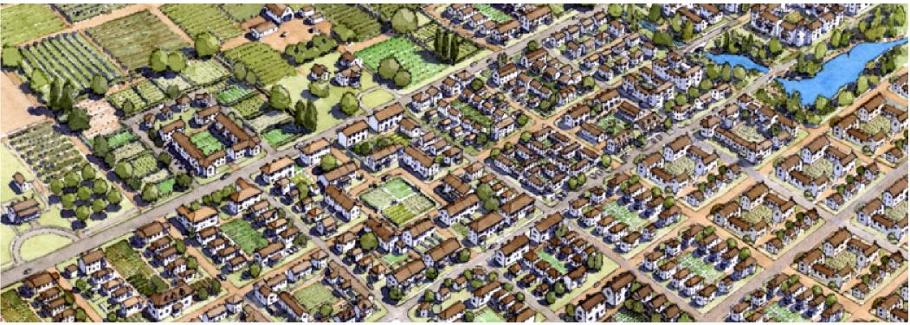

Appendix A: INDIANA CODE (IC) 36-7-4-1300
INDIANA SERIES IMPACT FEES
INDIANA CODE (IC) 36-7-4-1300
Assembled by:

Landscape Architects and Planners
Mishawaka, Indiana 46544

Valparaiso Recreation Zone Improvement Plan Study

INDIANA SERIES IMPACT FEES
INDIANA CODE (IC) 36-7-4-1300
IC 36-7-4-1300
Sec. 1300.
This series (sections 1300 through 1399 of this chapter) may be cited as follows: 1300 SERIES IMPACT FEES. As added by P.L.221-1991, Sec.1.
IC 36-7-4-1301
Sec. 1301.
As used in this series, “community level of service” means a quantitative measure of the service provided by the infrastructure that is determined by a unit to be appropriate.
As added by P.L.221-1991, Sec.2.
IC 36-7-4-1302
Sec. 1302.
As used in this series, “current level of service” means a quantitative measure of service provided by existing infrastructure to support existing development.
As added by P.L.221-1991, Sec.3.
IC 36-7-4-1303
Sec. 1303.
As used in this series, “development” means an improvement of any kind on land.
As added by P.L.221 -1991, Sec.4.
IC 36-7-4-1304
Sec. 1304.
(a) As used in this series, “fee payer” means the following:
- A person who has paid an impact fee.
- A person to whom a person who paid an impact fee has made a written assignment of rights concerning the impact fee.
- A person who has assumed by operation of law the rights concerning an impact fee.
(b) As used in this series, “person” means an individual, a sole proprietorship, a partnership, an association, a corporation, a fiduciary, or any other entity. As added by P.L.221-1991, Sec.5.
IC 36-7-4-1305
Sec. 1305.
- As used in this series, “impact fee” means a monetary charge imposed on new development by a unit to defray or mitigate the capital costs of infrastructure that is required by, necessitated by, or needed to serve the new development.
- As used in this Section, “capital costs” means the costs incurred to provide additional infrastructure to serve new development, including the following:
(1) Directly related costs of construction or expansion of infrastructure that is necessary to serve the new development, including reasonable design, survey, engineering, environmental, and other professional fees that are directly related to the construction or expansion.
(2) Directly related land acquisition costs, including costs incurred for the following:
- Purchases of interests in land.
- Court awards or settlements.
- Reasonable appraisal, relocation service, negotiation service, title insurance, expert witness, attorney, and other professional fees that are directly related to the land acquisition.
(3) Directly related debt service, subject to Section 1330 of this chapter.
(4) Directly related expenses incurred in preparing or updating the comprehensive plan or zone improvement plan, including all administrative, consulting attorney, and
other professional fees, as limited by Section 1330 of this chapter. As added by P.L.221-1991, Sec.6.
IC 36-7-4-1306
Sec. 1306.

Valparaiso Recreation Zone Improvement Plan Study

As used in this series, “impact fee ordinance” means an ordinance adopted under Section 1311 of this chapter. As added by P.L.221-1991, Sec.7.
IC 36-7-4-1307
Sec. 1307.
As used in this series, “impact zone” means a geographic area designated under Section 1315 of this chapter. As added by P.L.221-1991, Sec.8.
IC 36-7-4-1308
Sec. 1308.
As used in this series, “infrastructure” means the capital improvements that:
(1) comprise:
- a sanitary sewer system or wastewater treatment facility;
- a park or recreational facility;
- a road or bridge;
- a drainage or flood control facility; or
- a water treatment, water storage, or water distribution facility;
(2) are:
(A) owned solely for a public purpose by:
- a unit; or
- a corporation created by a unit; or
(B) leased by a unit solely for a public purpose; and
(3) are included in the zone improvement plan of the impact zone in which the capital
improvements are located. The term includes site improvements or interests in real property needed for a facility
listed in subdivision (1). As added by P.L.221 -1991, Sec.9.
IC 36-7-4-1309
Sec. 1309.
As used in this series, “infrastructure type”
means any of the following types of infrastructure covered by an impact fee
ordinance:
- Sewer, which includes sanitary sewerage and wastewater treatment facilities.
- Recreation, which includes parks and other recreational facilities.
- Road, which includes public ways and bridges.
- Drainage, which includes drains and flood control facilities.
- Water, which includes water treatment, water storage, and water distribution facilities.
As added by P.L.221-1991, Sec.10.
IC 36-7-4-1310
Sec. 1310.
As used in this series, “infrastructure agency” means a political subdivision or an agency of a political subdivision responsible for acquiring, constructing, or providing a particular infrastructure type. As added by P.L.221-1991, Sec.11.
IC 36-7-4-1311
Sec. 1311.
- The legislative body of a unit may adopt an ordinance imposing an impact fee on new development in the geographic area over which the unit exercises planning and zoning jurisdiction. The ordinance must aggregate the portions of the impact fee attributable to the infrastructure types covered by the ordinance so that a single and unified impact fee is imposed on each new development.
- If the legislative body of a unit has planning and zoning jurisdiction over the entire geographic area covered by the impact fee ordinance, an ordinance adopted under this Section shall be adopted in the same manner that zoning ordinances are adopted under the 600 SERIES of this chapter.
- If the legislative body of a unit does not have planning and zoning jurisdiction over the entire geographic area covered by the impact fee

Valparaiso Recreation Zone Improvement Plan Study

ordinance but does have jurisdiction over one (1) or more infrastructure types in the area, the legislative body shall establish the portion of the impact fee schedule or formula for the infrastructure types over which the legislative body has jurisdiction. The legislative body of the unit having planning and zoning jurisdiction shall adopt an impact fee ordinance containing that portion of the impact fee schedule or formula if:
- a public hearing has been held before the legislative body having planning and zoning jurisdiction; and
- each plan commission that has planning jurisdiction over any part of the geographic area in which the impact fee is to be imposed has approved the proposed impact fee ordinance by resolution.
- An ordinance adopted under this Section is the exclusive means for a unit to impose an impact fee. An impact fee imposed on new development to pay for infrastructure may not be collected after January 1, 1992, unless the impact fee is imposed under an impact fee ordinance adopted under this chapter.
- Notwithstanding any other provision of this chapter, the following charges are not impact fees and may continue to be imposed by units:
(1) Fees, charges, or assessments imposed for infrastructure services under statutes in existence on January 1, 1991, if:
- the fee, charge, or assessment is imposed upon all users whether they are new users or users requiring additional capacity or services;
- the fee, charge, or assessment is not used to fund construction of new infrastructure unless the new infrastructure is of the same type for which the fee, charge, or assessment is imposed and will serve the payer; and
- the fee, charge, or assessment constitutes a reasonable charge for the services provided in accordance with IC 36-1-3-8(6) or other governing statutes
requiring that any fees, charges, or assessments bear a reasonable relationship to the infrastructure provided.
(2) Fees, charges, and assessments agreed upon under a contractual agreement entered into before April 1, 1991, or fees, charges, and assessments agreed upon under a contractual agreement, if the fees, charges, and assessments are treated as impact deductions under Section 1321(d) of this chapter if an impact fee ordinance is in effect. As added by P.L.221-1991, Sec.12.
IC 36-7-4-1312
Sec. 1312.
(a) A unit may not adopt an impact fee ordinance under Section 1311 of this series unless the unit has adopted a comprehensive plan under the 500 SERIES of this chapter for the geographic area over which the unit exercises planning and zoning jurisdiction.
(b) Before the adoption of an impact fee ordinance under Section 1311 of this chapter, a unit shall establish an impact fee advisory committee. The advisory committee shall:
- be appointed by the executive of the unit;
- be composed of not less than five (5) and not more than ten (10 )members with at least forty percent (40%) of the membership representing the development, building, or real estate industries; and
- serve in an advisory capacity to assist and advise the unit with regard to the adoption of an impact fee ordinance under Section 1311 of this chapter.
(c) A planning commission or other committee in existence before the adoption of an impact fee ordinance that meets the membership requirements of subsection (b) may serve as the advisory committee that subsection (b) requires.
(d) Action of an advisory committee established under subsection (b) is not required as a prerequisite for the unit in adopting an impact

Valparaiso Recreation Zone Improvement Plan Study

fee ordinance under Section 1311 of this chapter.
As added by P.L.221-1991, Sec.13.
IC 36-7-4-1313
Sec. 1313.
This series does not prohibit a unit from doing any of the following:
(1) Imposing a charge to pay the
administrative, plan review, or inspection costs associated with a permit for development.
(2) Imposing, pursuant to a written
commitment or agreement and as a condition or requirement attached to a development approval or authorization (including permitting or zoning decisions), an obligation to dedicate, construct, or contribute goods, services, land or interests in land, or infrastructure to a unit or to an infrastructure agency. However, if the unit adopts or has already adopted an impact fee ordinance under Section 1311 of this chapter the following apply:
- The person dedicating, contributing, or providing an improvement under this subsection is entitled to a credit for the improvement under Section 1335 of this chapter.
- The cost of complying with the condition or requirement imposed by the unit under this subdivision may not exceed the impact fee that could have been imposed by the unit under Section 1321 of this chapter for the same infrastructure.
(3) Imposing new permit fees, charges, or assessments or amending existing permit fees, charges, or assessments. However, the permit fees, charges, or assessments must meet the requirements of Section 1311 (e) (1) (A), 1311 (e) (1) (B), and 1311 (e) (1) (C) of this chapter. As added by P.L.221-1991, Sec.14.
IC 36-7-4-1314
Sec. 1314.
(a) Except as provided in subsection (b), an impact fee ordinance must apply to any development:
- that is in an impact zone; and
- for which a unit may require a structural building permit.
(b) An impact fee ordinance may not apply to an improvement that does not create a need for additional infrastructure, including the erection of a sign, the construction of a fence, or the interior renovation of a building not resulting in a change in use. As added by P.L.221-1991, Sec.15.
IC 36-7-4-1315
Sec. 1315.
- An impact fee ordinance must establish an impact zone, or a set of impact zones, for each infrastructure type covered by the ordinance. An impact zone established for a particular infrastructure type is not required to be congruent with an impact zone established for a different infrastructure type.
- An impact zone may not extend beyond the jurisdictional boundary of an infrastructure agency responsible for the infrastructure type for which the impact zone was established, unless an agreement under IC 36-1-7 is entered into by the infrastructure agencies.
- If an impact zone, or a set of impact zones, includes a geographic area containing territory from more than one (1) planning and zoning jurisdiction, the applicable legislative bodies and infrastructure agencies shall enter into an agreement under IC 36-1-7 concerning the collection, division, and distribution of the fees collected under the impact fee ordinance. As added by P.L.221-1991, Sec.16.
IC 36-7-4-1316
Sec. 1316.

Valparaiso Recreation Zone Improvement Plan Study

A unit must include in an impact zone designated under Section 1315 of this chapter the geographical area necessary to ensure that:
- there is a functional relationship between the components of the infrastructure type in the impact zone;
- the infrastructure type provides a reasonably uniform benefit throughout the impact zone; and
- all areas included in the impact zone are contiguous. As added by P.L.221-1991, Sec.17.
IC 36-7-4-1317
Sec. 1317.
A unit must identify in the unit’s impact fee ordinance the infrastructure agency that is responsible for acquiring, constructing, or providing each infrastructure type included in the impact fee ordinance. As added by P.L.221-1991, Sec.18.
IC 36-7-4-1318
Sec. 1318.
(a) A unit may not adopt an impact fee ordinance under Section 1311 of this chapter unless the unit has prepared or substantially updated a zone improvement plan for each impact zone during the immediately preceding one (1) year period. A single zone improvement plan may be used for two (2) or more infrastructure types if the impact zones for the infrastructure types are congruent.
(b) Each zone improvement plan must contain the following information:
- A description of the nature and location of existing infrastructure in the impact zone.
- A determination of the current level of service.
- Establishment of a community level of service. A unit may provide that the unit’s current level of
service is the unit’s community level of service in the zone improvement plan. An estimate of the nature and location of development that is expected to occur in the impact zone during the following ten (10) year period.
- An estimate of the nature, location, and cost of infrastructure that is necessary to provide the community level of service for the development described in subdivision. The plan must indicate the proposed timing and sequencing of infrastructure installation.
- A general description of the sources and amounts of money used to pay for infrastructure during the previous five (5) years.
(c) If a zone improvement plan provides for raising the current level of service to a higher community level of service, the plan must:
- provide for completion of the infrastructure that is necessary to raise the current level of service to the community level of service within the following ten (10) year period;
- indicate the nature, location, and cost of infrastructure that is necessary to raise the current level of service to the community level of service; and
- identify the revenue sources and estimate the amount of the revenue sources that the unit intends to use
to raise the current level of service to the community level of service for existing development. Revenue sources include, without limitation, any increase in revenues available from one (1) or more of the following:
(A) Adopting or increasing the following:
- The county adjusted gross income tax.
- The county option income tax.
- The county economic development income tax.
- The annual license excise surtax.
- The wheel tax.
(B) Imposing the property tax rate per one
hundred dollars ($100) of assessed

Valparaiso Recreation Zone Improvement Plan Study

valuation that the unit may impose to create a cumulative capital
improvement fund under IC 36-9-14.5 or IC 36-9-15.5.
- Transferring and reserving for infrastructure purposes other general revenues that are currently not being used to pay for capital costs of infrastructure.
- Dedicating and reserving for infrastructure purposes any newly available revenues, whether from
federal or state revenue sharing programs or from the adoption of newly authorized taxes.
- A unit must consult with a qualified engineer licensed to perform engineering services in Indiana when the unit is preparing the portions of the zone improvement plan described in subsections (b) (1),(b) (2),(b) (5), and (c) (2).
- A zone improvement plan and amendments and modifications to the zone improvement plan become effective after adoption as part of the comprehensive plan under the 500 SERIES of this chapter or adoption as part of the capital improvements program under Section 503(5) of this chapter. If the unit
establishing the impact
fee schedule or formula and establishing the zone improvement plan is different from the unit having planning and zoning jurisdiction, the
unit having planning and zoning jurisdiction shall incorporate the zone improvement plan as part of the unit’s comprehensive plan and capital improvement plan.
- If a unit’s zone improvement plan identifies revenue sources for raising the current level of service to the community level of service, impact fees may not be assessed or collected by the unit unless:
(1) before the effective date of the impact fee ordinance the unit has available or has adopted the revenue sources that the zone improvement plan specifies will be in effect before the impact fee ordinance becomes effective; and
(2) after the effective date of the impact fee ordinance the unit continues to provide adequate funds to defray the cost of raising the current level of service to the
community level of service, using revenue sources specified in the zone improvement plan or revenue sources other than impact fees. As added by P.L.221-1991, Sec.19.
IC 36-7-4-1319
Sec. 1319.
- A unit shall amend a zone improvement plan to make adjustments in the nature, location, and cost of infrastructure and the timing or sequencing of infrastructure installations to respond to the nature and location of development occurring in the impact zone. Appropriate planning and analysis shall be carried out before an amendment is made to a zone improvement plan.
- A unit may not amend an impact fee ordinance if the amendment makes a significant change in an impact fee schedule or formula or if the amendment designates an impact zone or alters the boundary of a zone, unless a new or substantially updated zone improvement plan has been approved within the immediately preceding one (1) year period. As added by P.L.221-1991, Sec.20.
IC 36-7-4-1320
Sec. 1320.
(a) An impact fee ordinance must include:
- a schedule prescribing for each impact zone the amount of the impact fee that is to be imposed for each infrastructure type covered by the ordinance; or
- a formula for each impact zone by which the amount of the impact fee that is to be imposed for each infrastructure type covered by the ordinance may be derived.
(b) A schedule or formula included in an impact fee ordinance must provide an objective and uniform standard for calculating impact fees

Valparaiso Recreation Zone Improvement Plan Study

that allows fee payers to accurately predict the impact fees that will be imposed on new development. As added by P.L.221-1991, Sec.21.
IC 36-7-4-1321
Sec. 1321.
(a) An impact fee schedule or formula described in Section 1320 of this chapter shall be prepared so that the impact fee resulting from the application of the schedule or formula to a development meets the requirements of this Section. However, this section does not require that a particular methodology be used in preparing the schedule or formula.
(b) As used in this Section, “impact costs” means a reasonable estimate, made at the time the impact fee is assessed, of the proportionate share of the costs incurred or to be incurred by the unit in providing infrastructure of the
applicable type in the impact zone that are necessary to provide the community level of service for the development. The amount of impact costs may not include the costs of infrastructure of the applicable type needed to raise the current level of service in the impact zone to the community level of service in the impact zone for development that is existing at the time the impact fee is assessed.
(c) As used in this Section, “non-local revenue” means a reasonable estimate, made at the time
the impact fee is assessed, of revenue that:
- will be received from any source (including but not limited to state or federal grants) other than a local government source; and
- is to be used within the impact zone to
defray the capital costs of providing
infrastructure of the applicable type.
(d) As used in this Section, “impact deductions” means a reasonable estimate, made at the time the impact fee is assessed, of the amounts from the following sources that will be paid during the ten (10) year period after assessment of the impact fee to defray the capital costs of providing infrastructure of the applicable types
to serve a development:
- Taxes levied by the unit or on behalf of the unit by an applicable infrastructure agency that the fee payer and future owners of the development will pay for use within the geographic area of the unit.
- Charges and fees, other than fees paid by the fee payer under this chapter, that are imposed by any of the following for use within the geographic area of the unit:
- An applicable infrastructure agency.
- A governmental entity.
- A not-for-profit corporation created for governmental purposes. Charges and fees covered by this subdivision include tap and availability charges paid for extension of services or the provision of infrastructure to the development.
(e) An impact fee on a development may not exceed:
- impact costs; minus
- the sum of non-local revenues and impact deductions. As added by P.L.221-1991, Sec.22.
IC 36-7-4-1322
Sec. 1322.
(a) Except as provided in subsection (b), an impact fee ordinance must require that, if the fee payer requests, an impact fee on a development must be assessed not later than thirty (30) days after the earlier of:
- the date the fee payer obtains an improvement location permit for the development; or
- the date that the fee payer voluntarily submits to the unit a development plan for the development and evidence that the property is properly zoned for the proposed development. The plan shall be in the form prescribed by the unit’s zoning ordinance and shall contain reasonably sufficient detail for the unit to calculate the impact fee.

Valparaiso Recreation Zone Improvement Plan Study

(b) An impact fee ordinance may provide that if a proposed development is of a magnitude that will require revision of the zone improvement plan in order to appropriately serve the new
development, the unit shall revise the unit’s zone improvement plan and shall assess an impact fee on a development not later than one hundred eighty (180) days after the earlier of the following:
- The date on which the fee payer obtains an improvement location permit for the development.
- The date on which the fee payer submits to the unit a development plan for a development and evidence that the property is properly zoned for the proposed development. The development plan must be in the form prescribed by the unit’s zoning ordinance and must contain reasonably sufficient detail for the unit to calculate the impact fee.
(c) An impact fee assessed under subsections (a) or (b) may be increased only if the structural building permit has not been issued for the development and the requirements of subsection (d) are satisfied. In the case of a phased development, only a portion of an impact fee assessed under subsection (a) or (b) that is attributable to the portion of the development for which a permit has not been issued may be increased if the requirements of subsection (d) are satisfied.
(d) Unless the improvement location permit or development plan originally submitted for the development is changed so that the amount of impact on infrastructure the development creates in the impact zone is significantly increased, an impact fee assessed under: (1) subsection (a) (1) or (b) (1) may not be increased for the period of the improvement location permit’s validity; and
(e) An impact fee assessed under subsection (a) or (b) shall be decreased if the improvement location permit or development plan originally submitted for the development is changed so
that the amount of impact on infrastructure that the development creates in the impact zone is significantly decreased. If a change occurs in the permit or plan that results in a decrease in the amount of the impact fee after the fee has been paid, the unit that collected the fee shall immediately refund the amount of the overpayment to the fee payer.
- If the unit fails to assess an impact fee within the period required by subsection (a) or (b), the unit may not assess an impact fee on the development unless the development plan originally submitted for the development is materially and substantially changed.
- Notwithstanding other provisions in this chapter, a unit may not assess an impact fee against a development if:
- an improvement location permit has been issued for all or a part of a development before adoption of an impact fee ordinance that is in compliance with this chapter; and
- the development satisfies all of the following criteria:
- The development is zoned for commercial or industrial use before January 1, 1991.
- The development will consist primarily of new buildings or structures. As used in this clause, the term “new buildings or structures” does not include additions or expansions of existing buildings or structures.
- The parts of the development for which a structural building permit has not been issued are owned or controlled by the person that owned or controlled the development on January 1, 1991.
- A structural building permit is issued for the development not more than four (4) years after the effective date of the impact fee ordinance.
- The development is part of a common scheme of development that:
(i) involves land that is contiguous;

Valparaiso Recreation Zone Improvement Plan Study

- involves a plan for development that includes a survey of the land, engineering drawings, and a site plan showing the anticipated size, location, and use of buildings and the anticipated location of streets, sewers, and drainage;
- if plan approval is required, resulted in an application being filed with an appropriate office, commission, or official of the unit before January 1, 1991, that resulted or may result in approval of any phase of the development plan referred to in item (ii);
- has been diligently pursued since January 1, 1991;
- resulted before January 1, 1991, in a substantial investment in creating, publicizing, or implementing the common scheme of development; and
- involved the expenditure of significant funds before January 1, 1991, for the provision of improvements, such as roads, sewers, water treatment facilities, water storage facilities, water distribution facilities, drainage systems, or parks, that are on public lands or are available for other development in the area.
(h) Notwithstanding any other provision of this chapter, this chapter does not impair the validity of any contract between a unit and a fee payer that was:
- entered into before January 1, 1991; and
- executed in consideration of zoning amendments or annexations requested by the fee payer.
As added by P.L.221-1991, Sec.23.
IC 36-7-4-1323
Sec. 1323.
- Except as provided in Section 1324 of this chapter, an impact fee assessed in compliance with Section 1322 of this chapter is due and payable on the date of issuance of the structural building permit for the new development on which the impact fee is imposed.
- For a phased development, an impact fee shall be prorated for purposes of payment according to the impact of the parcel for which a structural building permit is issued in relation to the total impact of the development. In accordance with Section 1324 of this chapter, only the prorated portion of the assessed impact fee is due and payable on the issuance of the permit.
- If an impact fee ordinance is repealed, lapses, or becomes ineffective after the assessment of an impact fee on a development but before the issuance of the structural building permit for part or all of the development:
- any part of the impact fee attributable to the part of the development for which a structural building permit has not been issued is void and is not due and payable, in the case of a phased development; and
- the entire impact fee is void and is not due and payable, in the case of a development other than a phased development. As added by P.L.221-1991, Sec. 24.
IC 36-7-4-1324
Sec. 1324.
(a) An impact fee ordinance must include an installment payment plan. The installment payment plan must at least offer a fee payer the option of paying part of an impact fee in equal installment payments if the impact fee is greater than five thousand dollars ($5,000). In an installment plan under this Section:
- a maximum of five thousand dollars ($5,000) or five percent (5%) of the impact fee, whichever is greater, may become payable on the date the structural building permit is issued for the development on which the fee is imposed;
- the first installment may not become due

Valparaiso Recreation Zone Improvement Plan Study

and payable less than one (1) year after the date the structural building permit is issued for the development on which the fee is imposed; and
(3) the last installment may not be due and payable less than two (2) years after the date the structural building permit is issued for the development on which the fee is imposed.
- An impact fee ordinance may require an impact fee of five thousand dollars ($5,000) or less to be paid in full on the date the structural
building permit is issued for the development on which the impact fee is imposed.
- An impact fee ordinance may provide that a reasonable rate of interest, not to exceed the prejudgment rate of interest in effect at the time the interest accrues, may be charged if the fee payer elects to pay in installments. If interest is charged, the ordinance must provide that interest accrues only on the portion of the impact fee that is outstanding and does not begin to accrue until the date the structural building permit is issued for the development or the part of the development on which the impact fee is imposed.
- An impact fee ordinance may provide that if all or part of an installment is not paid when due and payable, the amount of the installment shall be increased on the first day after the installment is due and payable by a penalty amount equal to ten percent (10%) of the installment amount that is overdue. If interest is charged under subsection (c), the interest shall be charged on the penalty amount. As added by P.L.221-1991, Sec. 25.
IC 36-7-4-1325
Sec. 1325.
(a) A unit may use any legal remedy to collect an impact fee imposed by the unit. A unit must bring an action to collect an impact fee and all penalties, costs, and collection expenses associated with a fee not later than ten (10) years after the fee or the prorated portion of the
impact fee first becomes due and payable.
- On the date a structural building permit is issued for the development of property on which the impact fee is assessed, the unit acquires a lien on the real property for which the permit is issued. For a phased development, the amount of the lien may not exceed the prorated portion of the impact fee due and payable in one (1)or more installments at the time the structural building permit is issued.
- A lien acquired by a unit under this Section is not affected by a sale or transfer of the real property subject to the lien, including the sale, exchange, or lease of the real property under IC 36-1-11.
- A lien acquired by a unit under this Section continues for ten (10) years after the impact fee or the prorated portion of the impact fee becomes due and payable. However, if an action to enforce the lien is filed within the ten (10) year period, the lien continues until the termination of the proceeding.
- A holder of a lien of record on any real property on which an impact fee is delinquent may pay the delinquent impact fee and any penalties and costs. The amount paid by the lien holder is an additional lien on the real property in favor of the lien holder and is collectible in the same manner as the original lien.
- If a person pays an impact fee assessed against any real property, the person is entitled to a receipt for the payment that is:
- on a form prescribed by the impact fee ordinance; and
- issued by a person designated in the impact fee ordinance. As added by P.L.221-1991, Sec.26.
IC 36-7-4-1326
Sec. 1326.
(a) An impact fee ordinance may provide for a reduction in an impact fee for housing development that provides sale or rental housing, or both, at a price that is affordable to

Valparaiso Recreation Zone Improvement Plan Study

an individual or a family earning less than eighty percent (80%) of the median inc ome for the county in which the housing development is located. If the housing development comprises more than one (1) residential unit, the impact fee reduction shall apply only to the residential
units that are affordable to an individual or a family earning less than eighty percent (80%) of the median income of the county.
(b) If the impact fee ordinance provides for a reduction in an impact fee under subsection (a), the ordinance must:
(1) contain a schedule or formula that sets forth the amount of the fee reduction for various types of housing development specified in subsection (a);
(2) require that, as a condition of receiving the
fee reduction, the owner execute an agreement that:
- is binding for a period of at least five (5) years on the owner and subsequent owners; and
- limits the tenancy of residential units receiving the fee reduction to individuals or families who at the time the tenancy is initiated are earning less than eighty percent (80%) of the median income of the county;
(3) contain standards to be used in determining
if a particular housing development specified in subsection (a) will receive a fee reduction; and
(4) designate a board or an official of the unit
to conduct the hearing required by subsection (c).
(c) A fee reduction authorized by this Section must be approved by a board
or official of the unit at
a public hearing. As added by P.L.221-1991, Sec.27.
IC 36-7-4-1327
Sec. 1327. An impact fee ordinance must provide a procedure through which the fee reduction decision
made under Section 1326 of this chapter may be appealed by the following persons:
- The person requesting the fee reduction.
- An infrastructure agency responsible for infrastructure of the applicable type for the impact zone in which the impact fee reduction is granted. As added by P.L.221-1991, Sec.28.
IC 36-7-4-1328
Sec. 1328.
A unit that provides a fee reduction under Section 1326 of this chapter shall pay into the account or accounts established for the impact zone in which the fee was reduced an amount equal to the amount of the fee reduction. As added by P.L.221- 1 99 1 , Sec.29.
IC 36-7-4-1329
Sec. 1329.
(a) A unit imposing an impact fee shall establish a fund to receive amounts collected under this series.
(b) Money in a fund established under subsection (a) at the end of the unit’s fiscal year remains in the fund. Interest earned by the fund shall be deposited in the fund.
(c) The fiscal officer of the unit shall manage the fund according to the provisions of this series.
The fiscal officer shall annually report to the unit’s plan commission and to each infrastructure agency responsible for infrastructure in an impact zone. The report must include the following:
- The amount of money in accounts established for the impact zone.
- The total receipts and disbursements of the accounts established for the impact zone.
(d) A separate account shall be established in the fund for each impact zone established by the unit and for each infrastructure type within each zone. Interest earned by an account shall be deposited in that account. As added by P.L.221- 1 99 1 , Sec.30.

Valparaiso Recreation Zone Improvement Plan Study

IC 36-7-4-1330
Sec. 1330.
An impact fee collected under this series shall be used for the following purposes:
(1) Providing funds to an infrastructure agency for the provision of new infrastructure that:
- is necessary to serve the new development in the impact zone from which the fee was collected; and
- is identified in the zone improvement plan.
(2) In an amount not to exceed five percent (5%) of the annual collections of an impact fee, for expenses incurred by the unit that paid for the consulting services that were used to establish the impact fee ordinance.
(3) Payment of a refund under Section 1332 of this chapter.
(4) Payment of debt service on an obligation issued to provide infrastructure described in subdivision (1). As added by P.L.221-1991, Sec.31.
IC 36-7-4-1331
Sec. 1331.
(a) An infrastructure agency shall, within the time described in the zone improvement plan, construct infrastructure for which:
- a zone improvement plan has been adopted;
- an impact zone has been established; and
- an impact fee has been collected.
(b) A unit may amend the unit’s zone improvement plan, including the time provided in the plan for construction of infrastructure, only if the amount of expenditures provided for the construction of infrastructure in the original plan does not
decrease in any year and the benefit to the overall impact zone does not decrease because of the amendment. As added by P.L.221-1991, Sec.32.
IC 36-7-4-1332
Sec. 1332.
(a) A fee payer is entitled to a refund of an impact fee if an infrastructure agency:
(1) has failed to complete a part of the infrastructure for which the impact fee was imposed not later than:
- twenty-four (24) months after the time described in Section 1331 of this chapter; or
- a longer time as is reasonably necessary to complete the infrastructure if unforeseeable and extraordinary circumstances that are not in whole or in part caused by the unit have delayed the construction;
(2) has unreasonably denied the fee payer the use and benefit of the infrastructure during the useful life of the infrastructure; or
(3) has failed within the earlier of:
- six (6) years after issuance of the structural building permit; or
- the anticipated infrastructure completion date as specified in the zone improvement plan existing on the date the impact fee was collected; to make reasonable progress toward completion of the specific infrastructure for which the impact fee was imposed or thereafter fails to make reasonable progress toward completion.
(b) An application for a refund under subsection (a) must be filed with the unit that imposed the impact fee not later than two (2) years after the
right to a refund accrues. A unit shall issue a refund in part or in full or shall reject the application for refund not later than thirty (30) days after receiving an application for a refund.
(c) If a unit approves a refund in whole or in part, the unit shall pay the amount approved, plus interest from the date on which the impact fee was paid to the date the refund is issued. The interest rate shall be the same rate as the rate that the unit’s impact fee ordinance provides for

Valparaiso Recreation Zone Improvement Plan Study

impact fee payments paid in installments.
- If a unit rejects an application for refund or approves only a partial refund, the fee payer may appeal not later than sixty (60) days after the rejection or partial approval to the unit’s impact fee review board established under Section 1338 of this chapter by filing with the board an appeal on a form prescribed by the board. The board shall issue instructions for completion of the form. The form and the instructions must be clear, simple, and understandable to a lay person.
- An impact fee ordinance shall designate the employee or official of the unit who is responsible for accepting, rejecting, and paying a refund and interest.
- A unit’s impact fee review board shall hold a hearing on all appeals for a refund under this Section. The hearing shall be held not later than forty-five (45) days after the application for appeal is filed with the board. A unit’s impact fee review board shall provide notice of the application for refund to the infrastructure agency responsible for the infrastructure for which the impact fee was imposed.
- An impact fee review board holding a hearing under subsection (f) shall determine the amount of a refund that shall be made to the fee payer from the accou nt established for the infrastructure for which the fee was imposed. A refund ordered by the board must include interest from the date the impact fee was paid to the date the refund is issued
at the same rate the ordinance provides for impact fee payments paid in installments.
- A party aggrieved by a final decision of an impact fee review board in a hearing under subsection (f) may appeal to the circuit or superior court of the county in which the unit is located and is entitled to a trial de novo. As added by P.L.221-1991, Sec.33.
IC 36-7-4-1333
Sec. 1333.
(a) A person against whom an impact fee has been
assessed may appeal the amount of the impact fee. A unit may not deny issuance of a structural building permit on the basis that an impact fee has not been paid or condition
issuance of the
permit on the payment of an impact fee. However, in the case of an impact fee of one thousand dollars ($1,000) or less a unit may require a fee payer to:
- pay the impact fee; or
- bring an appeal under this Section; before the unit issues a structural building permit for the development for which the impact fee was assessed.
(b) A person must file a petition for a review of the amount of an impact fee with the unit’s impact fee review board not later than thirty (30) days after issuance of the structural building permit for the development for which the impact fee was assessed. An impact fee ordinance may require a petition to be accompanied by payment of a reasonable fee not to exceed one hundred dollars ($100). A fee payer shall receive a full refund of the filing fee if:
- the fee payer prevails;
- the amount of the impact fee or the reductions or credits against the fee is adjusted by the unit, the board, or a court; and
- the body ordering the adjustment finds that the amount of the fee, reductions, or credits were arbitrary or capricious.
(c) A unit’s impact fee review board shall prescribe the form of the petition for review of an impact fee under subsection (b). The board shall issue
instructions for completion of the form. The form and the instructions must be clear, simple, and understandable to a lay person. The form must require the petitioner to specify:
- a description of the new development on which the impact fee has been assessed;
- all facts related to the assessment of the impact fee; and
- the reasons the petitioner believes that the amount of the impact fee assessed is

Valparaiso Recreation Zone Improvement Plan Study

erroneous or is greater than the amount allowed by the fee limitations set forth in this series.
(d) A unit’s impact fee review board shall prescribe a form for a response by a unit to a petition for review under this Section. The board shall issue
instructions for completion of the form. The form must require the unit to indicate:
- agreement or disagreement with each item indicated on the petition for review under subsection (c); and
- the reasons the unit believes that the amount of the fee assessed is correct.
(e) Immediately upon the receipt of a timely filed petition on the form prescribed under subsection (c), a unit’s impact fee review board shall provide a copy of the petition to the unit assessing the impact fee. The unit shall not later
than thirty (30) days after the receipt of the petition provide to the board a completed response to the petition on the form prescribed under subsection (d) . The board shall immediately forward a copy of the response form to the petitioner.
(f) An impact fee review board shall:
- review the petition and the response submitted under this Section; and
- determine the appropriate amount of the impact fee not later than thirty (30) days after submission of both petitions.
(g) A fee payer aggrieved by a final determination of an impact fee review board may appeal to the circuit or superior court of the county in which the unit is located and is entitled to a trial de novo. If the assessment of a fee is vacated by judgment of the court, the assessment of the impact fee shall be remanded to the board for correction of the impact fee assessment and further proceedings in accordance with law.
(h) If a petition for a review or an appeal of an impact fee assessment is pending, the impact fee is not due and payable until after the petition or appeal is finally adjudicated and the amount of the fee is determined. As added by
P.L.221-1991, Sec.34.
IC 36-7-4-1334
Sec. 1334.
An impact fee ordinance must set forth the reasons for which an appeal of the amount of an impact fee may be made. The impact fee ordinance must provide that an appeal of the amount of an impact fee may be made for the following reasons:
- A fact assumption used in determining the amount of an impact fee is incorrect.
- The amount of the impact fee is greater than the amount allowed under Sections 1320, 1321, and 1322 of this chapter. As added by P. L.221 -1991, Sec.35.
IC 36-7-4-1335
Sec. 1335.
(a) As used in this Section, “improvement” means an improvement under Section 1313(2) of this
chapter or a site improvement, land, or real property interest as follows:
(1) That is to be used for at least one (1)of the infrastructure purposes specified in Section 1309 of this chapter.
(2) That is included in or intended to be used relative to an infrastructure type for which the unit has imposed an impact fee in the impact zone.
(3) That is not a type of improvement that is uniformly required by law or rule for the type of development on which the impact fee has been imposed.
(4) That is or will be:
- public property; or
- furnished or constructed under requirements of the unit and is or will be available for use by other development in the area.
(5) That is beneficial to existing development and future development in the impact zone
and is not beneficial to only one (1) development.

Valparaiso Recreation Zone Improvement Plan Study

(6) That either:
- allows the removal of a component of infrastructure planned for the impact zone;
- is a useful addition to the zone improvement plan; or
- is reasonably likely to be included in a future zone improvement plan for the impact zone.
(7) That is:
(A) constructed, furnished, or guaranteed by a bond or letter of credit under a request by an authorized official of the:
- applicable infrastructure agency; or
- unit that imposed the impact fee; or
(B) required to be constructed or furnished under a written commitment that:
- is requested by an authorized official of the applicable infrastructure agency or the unit that imposed the impact fee;
- concerns the use or developing of the development against which the impact fee is imposed; and
- is made under Section 613, 614, or 921 of this chapter.
(b) A fee payer is entitled to a credit against an impact fee if the owner or developer of the development constructs or provides:
- infrastructure that is an infrastructure type for which the unit imposed an impact fee in the impact zone; or
- an improvement.
(c) A fee payer is entitled to a credit under this Section for infrastructure or an improvement that:
- is constructed or furnished relative to a development after January 1, 1989; and
- meets the requirements of this Section.
(d) The amount of a credi t allowed under this Section shall be determined at the date the impact fee is assessed. However, if an
assessment is not requested, the amount of the credit shall be determined at the time the structural building permit is issued. The amount of the credit shall be:
(1) determined by the:
- person constructing or providing the infrastructure or improvement; and
- applicable infrastructure agency; and
(2) equal to the sum of the following:
- The cost of constructing or providing the infrastructure or improvement.
- The fair market value of land, real property interests, and site improvements provided.
(e) The amount of a credit may be increased or decreased after the date the impact fee is assessed if, between the date the impact fee is assessed and the date the structural building permit is issued, there is a substantial and material change in the cost or value of the infrastructure or improvement that is constructed or furnished from the cost or value determined under subsection (d) . However, at the time the amount of a credit is determined under subsection (d), the person providing the infrastructure or improvement and the applicable infrastructure agency may agree that the amount of the credit may not be changed. The person providing the infrastructure or improvement may waive the person’s right to a credit under this Section. As added by P.L.221- 1 99 1 , Sec.36.
IC 36-7-4-1336
Sec. 1336.
(a) If the parties cannot agree on the cost or fair market value under Section 1335(d) of this chapter, the fee payer or the person constructing or providing the infrastructure or improvement may file a petition for determination of the amount of the credit with the unit’s impact fee review board not later than thirty (30) days after the structural building permit is issued for the development on which

Valparaiso Recreation Zone Improvement Plan Study

the impact fee is imposed. A petition under this subsection may be made as part of an appeal proceeding under Section 1334 of this chapter or may be made under this Section.
(b) An impact fee review board shall prescribe the form of the petition for determination of the amount of a credit under this Section. The board shall issue instructions for completion of the form. The form and the instructions must be clear, simple, and understandable to a lay person.
(c) An impact fee review board shall prescribe a form for a response by the applicable infrastructure agency to a petition under this Section for determination of a credit amount. The board shall issue instructions for completion of the form.
(d) Immediately after receiving a timely filed petition under this Section for determination of a credit amount, an impact fee review board shall provide a copy of the petition to the applicable infrastructure agency. Not later than thirty (30) days after receiving a copy of the petition, the infrastructure agency shall provide to the board a response on the form prescribed under subsection (c). The board shall immediately provide the petitioner with a copy of the infrastructure agency’s response.
(e) The impact fee review board shall:
- review a petition and response filed under this Section; and
- determine the amount of the credit not later than thirty (30) days after the response is filed.
(f) A fee payer aggrieved by a final determination of an impact fee review board under this Section:
- may appeal to the circuit or superior court of the county in which the unit is located; and
- is entitled to a trial de novo. As added by P.L.221-1991, Sec.37.
IC 36-7-4-1337
Sec. 1337.
An impact fee ordinance shall do the following:
- Establish a method for reasonably allocating credits to fee payers in situations in which the person providing infrastructure or an improvement is not the fee payer.
- Allow the person providing infrastructure or an improvement to designate in writing a reasonable and administratively feasible method of allocating credits to future fee payers. As added by P.L.221-1991, Sec.38.
IC 36-7-4-1338
Sec. 1338.
(a) Each unit that adopts an impact fee ordinance shall establ ish an impact fee review board consisting of three (3) citizen members appointed by the executive of the unit. A member of the board may not be a member of the plan commission. An impact fee ordinance must do the following:
- Set the terms the members shall serve on the board.
- Establish a procedure through which the unit’s executive shall appoint a temporary replacement member meeting the qualifications of the member being replaced in the case of conflict of interest.
(b) An impact fee review board must consist of the following members:
- One (1) member who is a real estate broker licensed in Indiana.
- One (1) member who is an engineer licensed in Indiana.
- One (1) member who is a certified public accountant.
(c) An impact fee review board shall review the amount of an impact fee assessed, the amount of a refund, and the amount of a credit using the following procedures:
(1) The board shall fix a reasonable time for the hearing of appeals.

Valparaiso Recreation Zone Improvement Plan Study

(2) At a hearing, each party may appear and present evi dence in person, by agent, or by attorney.
(3) A person may not communicate with a member of the board before the hearing with intent to influence the member’s action on a matter pending before the board.
(4) The board may reverse, affirm, modify, or otherwise establish the amount of an impact fee, a credit, a refund, or any combination of fees, credits, or refunds. For purposes of
this subdivision, the board has all the powers of the official of the unit from which the appeal is taken.
(5) The board shall decide a matter that the board is required to hear:
- at the hearing at which the matter is first presented; or
- at the conclusion of the hearing on the matter, if the matter is continued.
(6) Within five (5) days after making a decision,
the board shall provide a copy of the decision to the unit and the fee payer involved in the appeal.
(7) The board shall make written findings of fact to support the board’s decision. As added by P.L.221-1991, Sec.39.
IC 36-7-4-1339
Sec. 1339.
(a) This Section applies to a person having an interest in real property that may be subject to an impact fee ordinance if the development occurs on the property.
(b) A person may seek to:
- have a court determine under IC 34-26-1 any question of constructi on or validity arising under the impact fee ordinance; and
- obtain a declaration of rights, status, or other legal relations under the ordinance.
(c) The validity of an impact fee ordinance adopted by a unit or the validity of the application of the ordinance in a specific impact zone may be
challenged under this Section on any of the following grounds:
- The unit has not provided for a zone improvement plan in the unit’s comprehensive plan.
- The unit did not prepare or substantially update the unit’s zone improvement plan in the year preceding the adoption of the impact fee ordinance.
- The unit has not identified the revenue sources the unit intends to use to implement the zone improvement plan, if identification of the revenue sources is required under Section 1318 (c) of this chapter.
- The unit has not complied with the requirements of Section 1318(f) of this chapter.
- The unit has not made adequate revenue available to complete infrastructure improvements identified in the unit’s zone improvement plan.
- The impact fee ordinance imposes fees on new development that will not create a need for additional infrastructure.
- The impact fee ordinance imposes on new development fees that are excessive in relation to the infrastructure needs created by the new development.
- The impact fee ordinance does not allow for reasonable credits to fee payers.
- The unit imposed a prohibition or delay on new development to enable the unit to complete the adoption of an impact fee ordinance.
- The unit otherwise fails to comply with this series in the adoption of an impact fee ordinance. As added by P.L.221-1991, Sec.40. Amended by P.L.1-1998, Sec.206.
IC 36-7-4-1340
Sec. 1340.
(a) An impact fee ordinance may take effect not

Valparaiso Recreation Zone Improvement Plan Study
earlier than six (6) months after the date on which the impact fee ordinance is adopted by a legislative body.
(b) An impact fee may not be collected under an impact fee ordinance more than five (5) years after the effective date of the ordinance. However, a unit may adopt a replacement impact fee ordinance if the replacement impact fee ordinance complies with the provisions of this series. As added by P.L.221-1991, Sec.41.
IC 36-7-4-1341
Sec. 1341.
A unit may not prohibit or delay new de velopment to wait for the completion of all or a part of the process necessary for the development, adoption, or updating of an impact fee. As added by P.L.221- 1 99 1 , Sec.42.
IC 36-7-4-1342
Sec. 1342.
The general assembly finds that the powers of a local governmental unit to permit and provide for infrastructure are not limited by the provisions of this chapter except as expressly provided in this chapter. As added by P.L.221-1991, Sec.43.

Valparaiso Recreation Zone Improvement Plan Study
Appendix B:
Fixed Assets / Capital Improvements over the years 2010-2014
The following table illustrates the Fixed Assets / Capital Improvements implemented by the Valparaiso Park Department from 2010 to 2014. This information was provided by the City of Valparaiso.
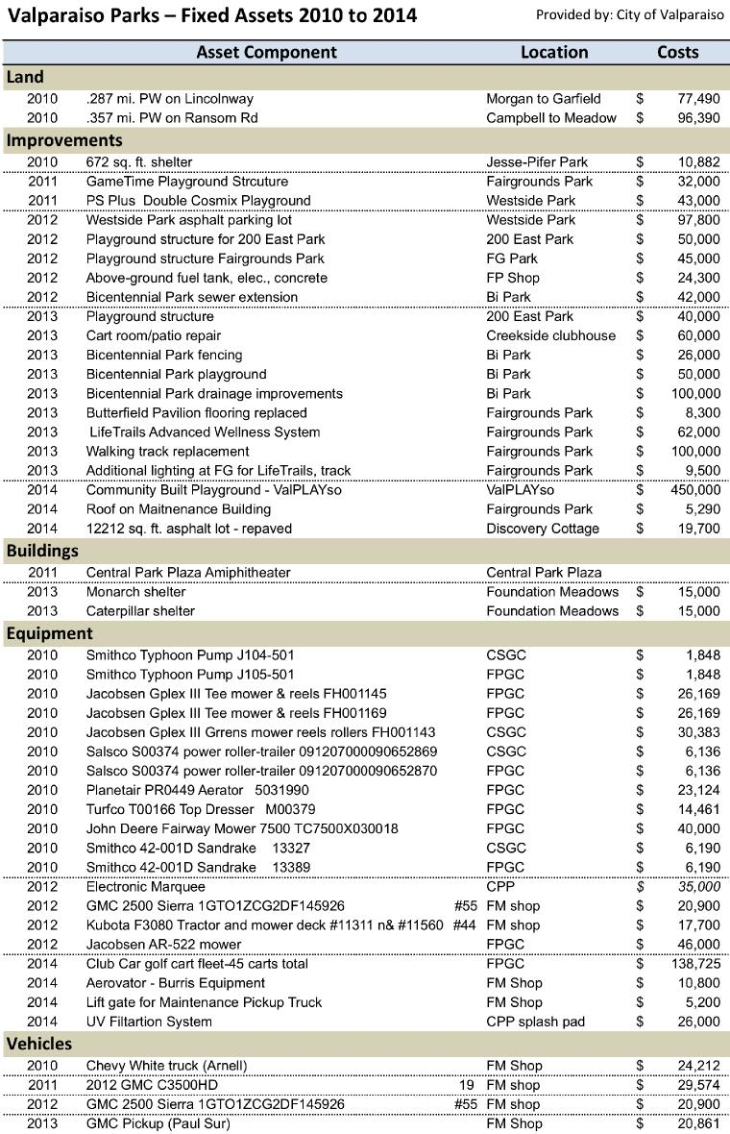

Appendix C:
Summary of Valparaiso Park Department Revenues 2009-2014
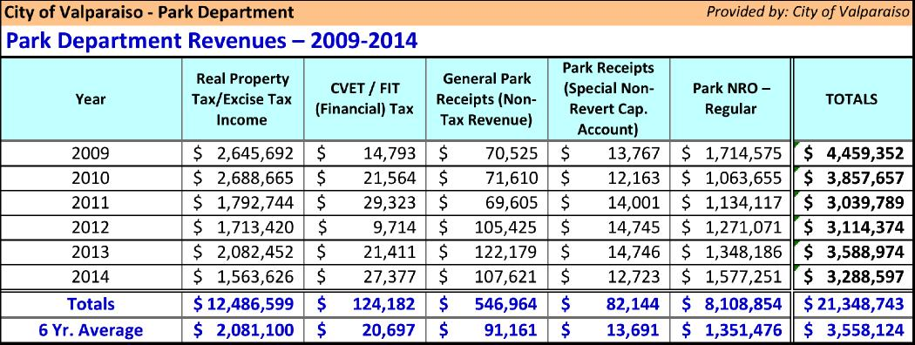
Appendix D:
Impact Fee One Zone Recommendation Logic
An Impact Zone needs to be established for each recreation infrastructure type covered by the ordinance. In studying multi-zone options it usually proves best to establish a one Impact Fee Zone. Refer to the below example of a one-zone vs. multi-zone option:
EXAMPLE
- Say one zone has 10 softball fields existing within it. The recreation standards when applied to the future population of that zone only requires 5 fields.
- Say in the next zone (which has no existing softball fields) when applying the recreation standards to its future population it calculates the need for 3 new fields.
Multiple Zones Sample Zone A Zone B
Existing Softball Inventory 10 0
Applied Softball Standard 5 3
Variance of Softball 5 (3)
Surplus Deficiency
- If you would have multiple zones (using the above example) you would need to develop an additional 3 softball fields providing a total inventory of 13 (existing plus new) or a total surplus of 5.
- Yet if these two zones would be part of the same the existing inventory of 10 fields would be more than enough with future needs of only 8 fields (5 existing plus 3 new).
One Zone Sample One Zone
Existing Softball Inventory 10
Applied Softball Standard 8
Variance of Softball 2
Surplus

Appendix E:  Park and  Recreation  Infrastructure Inventory | 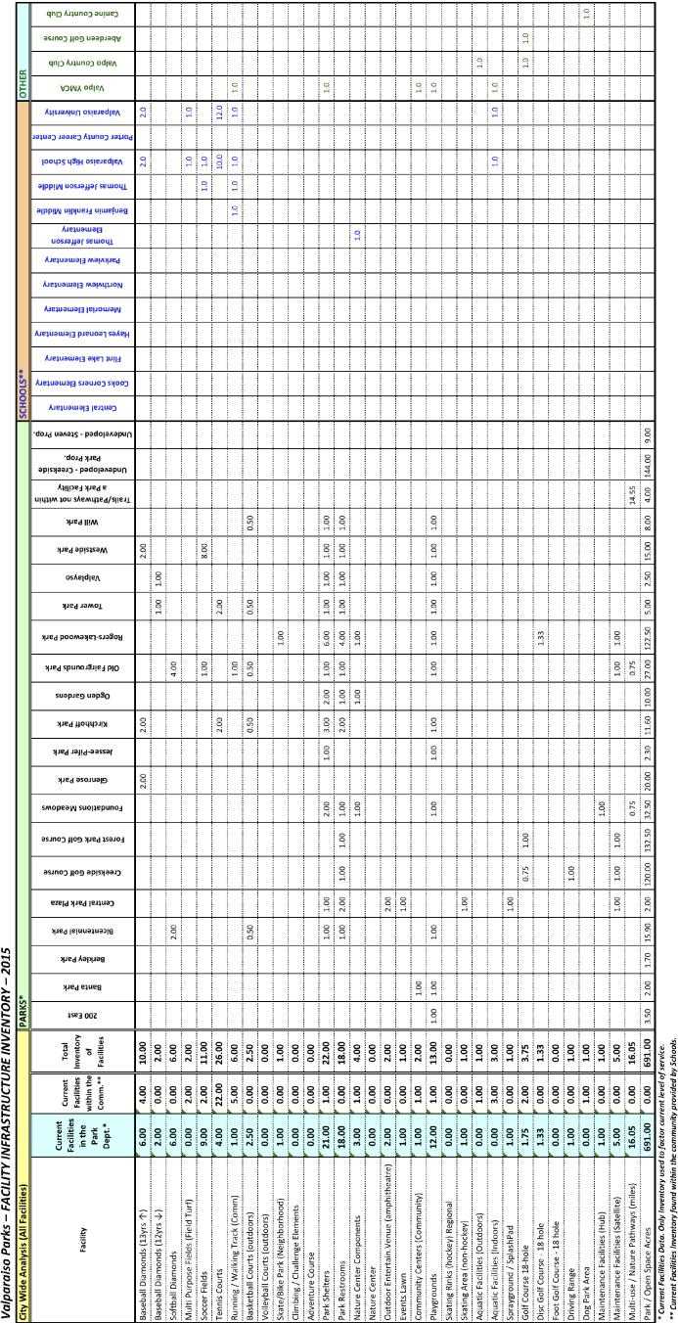

Appendix F:
RIF Collections and Disbursements 2005 to 2014
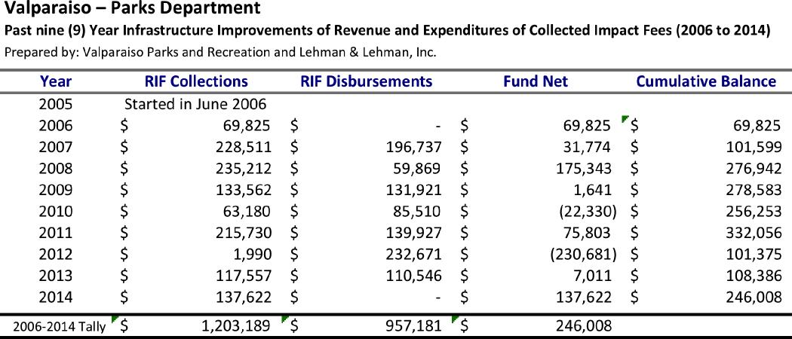
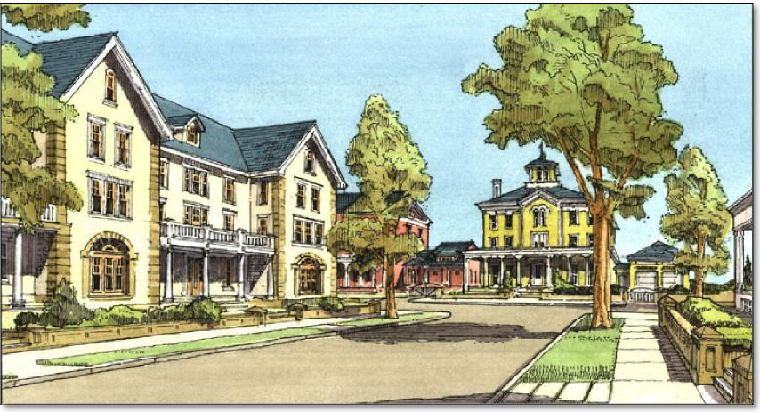

Appendix G:
Letter of Study Review from Reviewing Professional Engineer
The following is the Letter of Study Review done by the Reviewing Professional Engineer, Tim Burkman, P.E., City Engineer of the City of Valparaiso as per IC 36-7-4-1318(d).
